**Dynamics of *Teleaulax* cryptophytes during red water blooms in the Columbia River Estuary**

*Authors:*

Maria Hamilton 1,2, Joseph Needoba 3, Katie Maxey 3, Rhonda Morales 1, Tawnya D. Peterson 3, Megan Schatz 1, Jarred Swalwell 1, Peter Zuber 3, E. Virginia Armbrust 1, Francois Ribalet 1*

*Affiliations:*

1 School of Oceanography, University of Washington, Box 357940, Seattle, WA 98195 USA

2 Present address: Ocean Sciences Department, UC Santa Cruz, 1156 High Street, Santa Cruz, CA 95064

3 Institute of Environmental Health, Oregon Health & Science University, 3181 SW Sam Jackson Park Rd., Portland, OR 97239 USA

* Corresponding author: ribalet@uw.edu

**ABSTRACT (one page)**

Key results: The red water bloom that occurs yearly in the Columbia River Estuary is made up of both the mixotrophic ciliate, *M. major*, and its cryptophyte prey, *Teleaulax amphioxeia*. To better understand the dynamics of the 2013 bloom we employed the use of continuous flow cytometry to monitor the population of cryptophytes. We have found that there is a significant positive correlation between the abundances of the free-living *Teleaulax* cryptophytes and *M. major* populations during the bloom, which suggest a strong coupling between the availability of free-living prey and the abundance of *M. major*. Though influenced by physical processes within the estuary, tidal cycles did not significantly effect the abundances of the cryptophytes, indicating that this species is of estuarine origin.

*Teleaulax* division rate was determined using a previously developed size structured growth model, and was found to be negatively correlated with pH while positively correlated with concentrations of dissolved inorganic nutrients (DIN and DIP), highlighting the importance of pH and nutrient availability in the dynamics of *Teleaulax* and *M. major*.

Key words: cryptophytes; *Teleaulax; Mesodinium;* growth rates; SeaFlow; awesomeness

**INTRODUCTION**

The common coastal ciliate, *Mesodinium major*, previously referred to as *Mesodinium rubrum* (=*Myrionecta rubra*) (Lohmann, 1908; Jankowski, 1976), is among the marine microzooplankton that temporarily maintains the plastids of their cryptophyte algal prey, *Teleaulax amphioexa* (Herfort et al., 2011b). This association allows the ciliate to function as a mixotroph, capable of utilizing both phagotrophy and photosynthesis to acquire carbon (Crawford, 1989). Mixotrophic *M. major* populationsare now understood to be important primary producers in coastal and estuarine systems (Stoecker et al., 1989, Herfort et al., 2012). However, little is known about the ecology and physiology of the *T. amphioexa* prey and how their growth impacts the bloom dynamics of *M. major*.

Massive *M. major* blooms occur each year in the Columbia River estuary (CRE) and last for several months during the late summer and early fall (Herfort et al., 2011a), which shifts the estuary from net heterotrophy to net autotrophy (Herfort et al., 2012). The annual *M. major* bloom appears to be initiated during summer neap tides (Herfort et al., 2011a) when both tidal forcing and the seasonality of freshwater discharge result in an extended summer saltwater intrusion (Chawla et al., 2008) and a temporary decrease in turbulence. The bloom commonly starts in Baker Bay, where a shallow depth and high retention favor high cell abundances (>100 cells mL-1) and fast growth rates (1.2-3.1 d-1) of *M. major*. Within a few weeks, this initial bloom spreads throughout the main estuary covering XX km (Herfort et al., 2011a). A decline in the abundance of small (<5 µm), free-living *Teleaulax* cells coincided with an increase in *M. major* abundance observed in the CRE in 2011 (Peterson et al., 2013), suggesting a direct link between consumption of the cryptophyte prey and the initiation of an *M. major* bloom. In an Antarctic saline lake, however, an increase in the abundance of cryptophytes preceded the increase in abundance of *M. rubrum* (van den Hoff et al., 2015), perhaps reflecting a different time point in bloom development. Thus, the underlying mechanisms remain unclear for the observed correlations between the abundance of free-living cryptophyte prey and the development of *M. major* blooms.

At least part of this complication comes from the numerous factors that influence cell abundances, including cell division, cell mortality, and rapid physical transport such as observed in the CRE. We hypothesized that the rate of cell division of cryptophyte cells, rather than the standing stock, would better reflect the driving force for initiation of *M. major* blooms. Until recently, rate of cell division was a time consuming and difficult measurement (Laws 2012), however, it is now possible to use continuous flow cytometry measurements to estimate division rates based on changes in cell size distributions over the course of a day (Sosik et al., 2003; Hunter-Cevera et al., 2014; Ribalet et al., 2015). This new method eliminates many of the difficulties and biases associated with the determination of cell division rates using discrete sampling techniques.

Here, we apply this new approach to the study of cryptophyte division rates both in the laboratory and in the field. We determined how the division rate of the cryptophyte population is affected by environmental conditions, and how it influences, in turn, the dynamics of *M. major.* To do so, a 4-week survey was conducted in 2013 during which dissolved nutrients, salinity, temperature, light irradiance, and abundances of cryptophytes and *M. major* were measured during red water blooms in the CRE. The abundances and size distribution of the cryptophytes were determined using a continuous flow cytometer, SeaFlow (Swalwell et al., 2011). Daily division rates of cryptophytes were calculated from the change of size distribution over a 24-h period using the size-structured division rate model (Sosik et al., 2003).

**METHODS**

**Study Area**

Samples were collected at 2.4 m depth for 1 month, 4 days a week, from September 11th to October 2nd 2013 using a continuous seawater flow-through system of SATURN03, a fixed station located at the end of a dock in Hammond, OR (**fig. 1**) (Batista et al., 2015). Most discrete samples were collected during the turn of the high tide (i.e., at slack water).

**Hydrological conditions**

Water temperature, salinity and pH were measured continuously at SATURN-03 using a SeaBird <model> Conductivity-Temperature (CT) meter for temperature and salinity, and a Durafet pH sensor (Honeywell). Photosynthetic Active Radiation (PAR) data were obtained from Desdemona Sands Light mooring, located 3 km north of SATURN-03.

**Nutrient concentrations**

30 mL water samples for nutrient analysis were taken in duplicate.

JN writes this

**Determination ofcryptophyte cell abundance**

Continuous measurements of cryptophyte abundances and cell size were made using SeaFlow, (Swalwell et al., 2011). The instrument was equipped with a 457-nm 300-mW laser (Melles Griot). Forward light scatter (a proxy for cell size), red and orange fluorescence were collected using a 457–50 bandpass filter, 572–27 bandpass filter and 692–40 band-pass filter, respectively. Seawater was prefiltered through a 100-µm stainless steel mesh (to eliminate large particles) prior to analysis. The flow rate of the water stream was set at 15 mL min−1 through a 200-µm nozzle for field and laboratory experiment; this corresponded to an analysis rate of 15 µL min−1 by the instrument (Swalwell et al., 2011). A programmable syringe pump (Cavro XP3000, Hamilton Company) continuously injected fluorescent microspheres (1 µm, Polysciences) into the water stream as an internal standard. Data files were created every three minutes. Data were analyzed using the R package *Popcycle* version 0.2, which uses a SQLite relational database management system to retrieve flow cytometry data (<https://github.com/uwescience/popcycle>). A sequential bivariate manual gating scheme was used to cluster cryptophyte population based on orange fluorescence and forward light scatter measurements.

For the identification of cryptophytes cells, discrete samples for flow cytometry samples were collected once a day during slack tide, fixed with 0.025% glutaraldehyde and stored at -80 ºC. Six months after sample collection, fixed samples were analyzed with a BD Influx cell sorter. 100 cells from the gated population of high-orange particles (assumed to represent phycoerythrin-containing cryptophytescells) were sorted onto a glass slide. The cells were then examined under a Nikon Eclipse 80i epifluorescence microscope at 400x magnification and photographed using a Qimaging MicroPublisher 3.3 RTV camera.

**Estimates of cryptophyte cell division rates**

We used a size-structured matrix population model developed by Sosik et al. (2013) to estimate cryptophyte population division rates. We implemented Sosik’s original Matlab model in an R package *ssPopModel* version 0.1.1, available on Github (<https://github.com/armbrustlab/ssPopModel>). The model is based on the assumptions that 1) cell growth is determined by light exposure, with other abiotic factors such as nutrient availability and temperature operating at longer time scales, 2) the probability of a cell dividing depends on size, 3) all cells within a discrete size class have the same probability to change to another size class, and 4) a cell divides into two daughter cells, each half the size of the mother cell. The model predicts the cell size distribution over the course of the day using the cell size/cell division relationships and the light-dependence of cell division.

*Estimated division rates in cultures.*

A non-axenic culture of the cryptophyte *Rhodomonas* sp. (CCMP 755) was grown in the laboratory in natural seawater amended with f/2 nutrients at 13 °C with a 16:8 light-dark cycle of 100 µE m-2 s-1 provided by white fluorescent tubes. The culture was grown for 4 days in a 20-L batch culture and mixed with a magnetic carboy stir bar and analyzed with SeaFlow. On day 3, 1 mL samples of the culture were collected in triplicate every 2 hours for 28 hours, fixed with 0.01% glutaraldehyde and stored in liquid nitrogen. One month after sample collection, fixed samples were stained with 0.01% green-fluorescing DNA stain SYBR Green I (diluted with dimethylsulfoxide) for 15 minutes at room temperature in the dark. Following the addition of fluorescent microspheres (1 μm, Polysciences) used as internal standard, stained samples were analyzed with a BD Influx flow cytometer. Data were obtained using the *Spigot Operating Software* version 5.0 (BD Biosciences) and analyzed using *FlowJo* version 9.7.2 (Tree Star). A minimum of 10,000 cells wascollected per sample. DNA frequency distributions were analyzed using *FlowJo* cell cycle platform to obtain cell fractions in G1, S, and G2+M phases. Division rates based on DNA distributions were computed as described previously (Carpenter and Chang, 1988).

*Estimated division rates in the field.*

The method used to estimatehourly division rates of *Rhodomonas* sp*.* in culture was applied to cryptophyte populations in the field. Daily-averaged division rates were calculated as the sum of hourly division rates over a 24-h period.

**Cryptophyte community composition**

*DNA extraction*

Sample volumes of 0.5-2.0 L were filtered with a 20 μm filter followed by a 0.2 μm Sterivex filter. The size fractionation was performed to separate the *Teleaulax* symbiont in *M. major* cells from free living *Teleaulax.* Filters were fixed with 2 mL of RNAlater and stored at -80°C until extraction.

Samples were extracted using the CTAB method (Li et al., XXXX). Briefly, the filters are suspended in buffer and proteinase K in 2 ml microcentrifuge tubes and incubated at 55°C overnight. After this incubation, 165 μL each of 5M NaCl and 10% CTAB were added and incubated for an additional 10 min at 55°C. Approximately 600 μL of chloroform was added and the samples were then vortexed for 75 seconds, followed by centrifugation (13,000g) for 10 min. The DNA of the aqueous layer was purified using a DNA Clean and Concentrate Kit (Zymo Research). The total extracts were stored at -20°C until further use.

*Identification of the cryptophyte nuclear 28S D2 element*

A specific genetic marker was used to distinguish between *T. amphioxeia* and other free-living cryptophytes. This marker is the Unique Sequence Element (USE) found in the D2 region of the LSU rRNA sequence. The cryptophyte nuclear D2 region of the LSU was identified using the 28S D1-D5 sequence for the cryptophyte *Goniomonas truncata* (accession number FJ176709). A BLASTn search showed a large gap in sequence homology of around 300-400 bp near the 5’ end of the LSU. Primers were designed using Primer-BLAST to flank this gap region (crp28SF CTTGCTTGGGAATGCAGGTC /crp28SR TACGAGCCTCCACCAGAGTT). These primers were used with PCR to identify the LSU D2 of *Teleaulax*.Single cell PCR was performed on *M. major* cells from red water in the CRE collected in 2011 and 2014. The lab culture of the Antarctic strain of *M. rubrum* (CCMP2563) was used as a control, as it is fed with the cryptophyte *Geminigera cryophilia* (CCMP 2564)*.* The PCR protocol for the LSU D2 sequence identification is as follows: initial denaturation at 95°C for 3 min; 35 cycles of denaturation at 95°C for 45 sec, annealing at 50°C for 40 sec, and extension at 70°C for 2 min; and a final extension at 70°C for 7 min. The results of the PCR were visualized on a 1% agarose gel. The PCR products were purified (UltraClean PCR clean up kit, MoBio), ligated into a TOPO 2.1 vector (Invitrogen), and transformed into chemically competent *E. coli* cells (DH5α strain). The transformed cells were grown up overnight at 37°C on LB plates containing 40 μg mL-1 X-gal and 50 μg mL-1 Kanamycin. White colonies were selected and grown up overnight in a 37°C water bath shaker in 2X YT broth with 50 μg mL-1 Kanamycin. Miniprep (FastPlasmid Mini Kit, 5 Prime) was performed and the samples were sent to the Molecular and Cellular Biology Core of the ONPRC for sequencing. Sequences of around 650 bp were assembled and aligned using *Geneious* software version XXX.

Alignment between the *T. amphioxeia* and *G. cryophilia* D2 sequences identified a unique sequence element (USE) (Kahn et al., XXX) of around 220 bp. The *T. amphioxeia* USE was used as a species specific marker to track the free-living cryptophyte and *M. major* in the estuary. The specificity of the USE was demonstrated using FISH on red water and lab culture samples. A FISH probe labeled with the fluorophore Alexa488 [TxD2 FISH (Alexa 488 – AACACACGAGTTAAGATACCAATGGATCATTCACTCGCATGCCC)] was designed to hybridize to the 3’ end of the USE in *T. amphioxeia*. The probe was labeled with Alexa488 fluorophore. The probe was seen in the cytoplasm of both the ciliate and free cryptophytes in red water samples, but not in the laboratory *M. rubrum* culture.

The 28S D2 sequence was extended to the 3’ end of the 18S rRNA using the general eukaryotic 18S primer BMB-CR (GTACACACCGCCCGTCG)to Crp28SR. This region includes the 5S and ITS2. The 18S rRNA sequence generated was identical to that of *T. amphioxeia*.

*Real Time PCR*

The distribution and size of the cryptophyte and specific prey population was monitored in environmental samples by qPCR. Analysis was performed on a StepOnePlus Real Time PCR system (Life Technologies) using SYBR Green as the reporter dye and the following protocol: initial denaturation at 95 °C for 10 min; 40 cycles of denaturation at 95°C for 15 s, and extension and data acquisition at 60 °C for 1 min; followed by a melting curve analysis. The *T. amphioxeia* specific primers [TxD2 1F (TGAAAAAGGGCCTGAAATTG) /TxD2 USE 2R (ATCATTCACTCGCATGCCCC)] were used to amplify the USE of the prey cryptophyte. General cryptophyte primers [CrpSpecf 3F (GTTCTGAAGATGCTGGCACA)/ CrpSpecf 3R (GTTCTGAAGATGCTGGCACA)] were used to monitor total cryptophyte populations and calculate the ratio of prey to total cryptophytes. This sequence was downstream of the USE. Primers were designed using Primer-BLAST from NCBI and confirmed with PCR.

The Antarctic *M. rubrum* culture was used as a control (i.e., negative for prey-specific and positive for general-cryptophyte sequences). All environmental total extracts were diluted 10-fold before analysis to remove interfering compounds. All standards, samples and water blanks were analyzed in triplicate and 1 μL of DNA template was used in each reaction. Standards for qPCR were constructed with the *T. amphioxeia* LSU D2 region cloned into a TOPO 2.1 vector. This plasmid was used for both primer sets as it contained the *T. amphioxeia* specific USE and general cryptophyte sequences. A standard curve was generated from six standards with concentrations ranging from 9.289 x 106 – 9.289 x 101 D2 copies µL-1. Concentrations of the standards were calculated from Kahn et al. (XXXX). Concentrations of USE copies were determined with the following formula:

Copies/mL = abc/d

Where *a* is the copies μL-1 determined from qPCR, *b* is the volume in μL the extracted DNA was re-suspended in, *c* is the dilution factor and *d* is the volume in mL of the water sample.

***Mesodinium major* cell abundance**

45 mL samples fixed with 0.5% glutaraldehyde were collected into 50 mL centrifuge tubes for *M. major* counts and stored at -20 °C pending analysis. Prior to analysis, the samples were slowly thawed to 4 oC and analyzed using an imaging flow cytometer (FlowCAM, Fluid Imaging, Inc.). A minimum of 1000 particles with diameter >5 m were captured and the images were filtered using *VisualSpreadsheets* software version XX (Fluid Imaging, Inc.) according to size. Those resembling *M. major* were selected based on visual inspection and enumerated. Flow rates were calculated using *VisualSpreadsheets* software, allowing for the quantification of cellular abundances.

**RESULTS**

**Environmental conditions**

The Columbia River Estuary is a turbid and often highly stratified system characterized by its dynamic physical processes, short residence time (0.5-5 days) and strong influence from diurnal and semi-diurnal tides (Neal, 1972; Jay, 1984). Throughout the 4-week survey at SATURN03 (**Fig. S1**), surface water temperature and salinity were anti-correlated and oscillated with the tidal cycle, with high tide characterized by an influx of colder seawater, and low tide characterized by an increase of warmer freshwater. The survey began and ended during neap tides (weeks 1, 3, and 4). Spring tide, occurred during the second week of the survey, and it was during this time that the highest surface water salinity and lowest temperature were observed. The lowest salinity was observed on the second neap tide, with little variations in temperature over the tidal cycle (**Fig. 1A**). The average surface water temperature and salinity during the survey were 17.5 °C and 12 psu, respectively.

The variations of pH were correlated with tidal cycles, with values increasing during flood tides that ranged from 7.8 to 8.4 (**Fig. 1B**). The lowest pH values were observed at day 3 and increased progressively later on. Changes in concentrations of dissolved inorganic phosphate (DIP) and nitrogen (DIN as the sum of nitrate, nitrite and ammonium) co-varied throughout the survey, with nutrient concentrations initially stable then increasing by the end of the first neap tide. They decreased during the spring tide and remained relatively stable later on (**Fig. 1C**). DIP and DIN concentrations were negatively correlated with pH (R2 = 0.47 and 0.34, p< 0.05, respectively) (**Fig. S2**).

Red fluorescence, a measurement generally considered to be a proxy for phytoplankton biomass, was low for the duration of the first week (first neap tide) of the survey, but then increased and reached the highest values by the end of the spring tide (Fig. 1B). There also appeared to be a positive relationship between fluorescence and tidal cycle, with values increasing with high salinity and the corresponding flood tide.

**Cell abundances**

The small size (<5 µm in length) and teardrop shape of the cryptophyte cell population sorted with the flow cytometer and observed under light microscope (**Fig. 2**) agreed with past observations of *Teleaulax amphioexa* cells (Peterson et al., 2013). We therefore assumed that the cryptophyte cell population measured by the SeaFlow represented *Teleaulax amphioexa* population during the survey.

Hourly-averaged cell abundances of *T. amphioxeia* measured ranged from 0.02 x 106 to 1.8 x 106 cells L-1, with an average of 0.29 x 106 cells L-1 (**Fig. 3**). Cell abundance obtained with the SeaFlow were in excellent agreement with discrete samples analyzed by conventional flow cytometry (R2 = 0.83, p < 0.01, **Fig. S3**). Although variations in cell abundance occurred within individual days, changes in cell abundance did not coincide with daily tidal cycle. No significant correlation was observed between *T. amphioxeia* cell abundances and salinity (data not shown). The highest abundances of *T. amphioxeia* were observed during the first two days of the survey during the first neap tide, with daily-averaged abundance of 0.52 x 106 cells L-1, (**Fig. 3A**). Week 2 (spring tide) and week 3 (neap tide) exhibited the lowest abundances, with an average of 0.08 x 106 cells L-1 and 0.09 x 106 cells L-1, respectively (**Fig. 3B and C**).

The abundances of *T. amphioxeia* at high-tide were comparable to the abundances of *M. major*, with values varying from 0.021 x 106 to 0.32 x 106 cells L-¹ during the survey (**Fig. 3**). A positive correlation between abundances of *T. amphioxeia* and *M. major* was observed during the survey (R2 = 0.24, p < 0.01) (**Fig. S4**). Except at day 10, abundances of *M. major* were lower than those of *Teleaulax*. Abundances of *T. amphioxeia* and *M. major* during the survey were not significantly correlated with environmental conditions such as nutrient concentrations, and no relationship between abundances and neap/spring tide could be determined. (data not shown).

**Division rates**

To establish the accuracy of size distribution-based division rate estimates using SeaFlow measurements of forward-angle light scattering converted to cell volume using an empirical relationship (Ribalet et al. 2015), we compared size-based estimates of division rates (h-1) with cell-cycle based estimates of division rates for the cryptophyte *Rhodomonas*. The hourly division rates estimated using both cell cycle analysis and the model followed the same general trend throughout the experiment (**Fig.** **4**), although some discrepancies occurred around dawn (at hour 1, 3 and 27). The coefficients of determination R2 = 0.60 (p < 0.001) (**Fig.** **S5**) indicates that the model provides reasonable estimates of division rate for the cryptophyte *Rhodomonas* in culture*.* In the field, our limited access to the sampling site prevented us to use the cell-cycle method to validate our model-based estimates of division rates for *T. amphioxeia*. During the 4-week survey, changes in the size distribution of *T. amphioxeia* followed the day/night cycle (**Fig.** **5A**). No effect of the tidal cycle was observed on the cryptophyte size distribution, which is consistent with the model assumptions that photosynthesis and cell division are the main factors influencing the change of cell volume over a 24-h period (Sosik et al. 2003).

Estimates of the daily division rates of *T. amphioxeia* ranged from 0.2 ± 0.1 d-1 to 1.5 ± 0.1 d-1 (**Fig. 5**), which correspond to 0.3 and 2.1 division per day, respectively. The highest division rate was observed at day 3 and coincided with the lowest pH values (**Fig. 2C**). Division rates were positively correlated with concentrations of dissolved inorganic nutrients (R2 = 0.44 and 0.30, p < 0.05, for DIP and DI, respectively) and negatively correlated with pH during the survey (R2 = 0.41, p < 0.05) (**Fig. S6**), with decreasing division rates observed with daily-averaged pH > 8.0. No significant correlation was observed between division rates and other environmental factors such as temperature (data not shown).

**Cryptophyte community composition**

The percent of *Teleaulax amphioexa* to the total cryptophytes was always less than 1% (0.06% to 0.40%; **Table 1**), with the highest percent of *T. amphioexa* occurring just prior to the first week and the lowest percent on the second week of the survey similar to the cell abundances of *T. amphioxeia* (**Fig. 3**).

Fill this section in with more data from Katie/Peter

**DISCUSSION**

The continuous method used in this study circumvents many of the limitations associated with traditional discrete sampling method when monitoring plankton populations in a dynamic system such as the CRE. Our results show that cell abundances of cryptophytes can shift dramatically over the course of just a few hours and highlight the importance of physical process in the dynamics of plankton population in the CRE. Such variability in cell abundance should be taken into consideration when interpreting results from data extrapolated from a few data points and emphasized the importance of continuous measurements for monitoring phytoplankton in the CRE.

The model utilized to determine division rates relies on a number of important assumptions, including the assumption that the population of interest consists of a single taxonomic group. It is possible that multiple taxonomic groups of cryptophytes with different physiologies are represented within the population of cryptophytes that we observe with SeaFlow, despite the consistent morphology seen among the sorted population. However, we do not actually have any evidence that connects this possible model assumption violation to any potential errors in our division rate estimates. Furthermore, our validation of the model on a laboratory culture of cryptophytes confirms the model’s ability to accurately estimate the division rates of these eukaryotic phytoplankton.

**Ecophysiology of the *Teleaulax amphioexa*** **during the survey**

The cryptophyte *Teleaulax amphioexa* is a marine species distributed in coastal habitats worldwide. During our survey, no consistent increase in *T. amphioxeia* cell abundance was observed with seawater intrusion, and variations in abundances were not related to the high/low or spring/neap tidal cycles. These results suggest that *T. amphioxeia* distribution is very patchy within the CRE, and arehighlight the importance of physical transport in the dynamics of *T. amphioxeia* in the estuary, potentially making interpretation of changes in cell abundance difficult. But the analysis of population statistics is likely to be a sufficient way of avoiding the problems associated with rapid transport in the estuary, considering the high time resolution of the abundance data collected in this survey. Additionally, the lack of a relationship between *T. amphioxeia* cell abundance and tidal cycle is in direct contrast with our measurements of red fluorescence, which exhibit a strong correlation with the incoming tide. It is likely that *T. amphioxeia* only makes up a small proportion of the red fluorescence, and other species of phytoplankton that dominate the signal, including *M. major*, are of marine origin.

To the best of our knowledge, this study is the first to attempt to estimate division rates of cryptophyte species in the field. Laboratory estimates of *T. amphioxeia* division rates under nutrient replete conditions range from 0.3 to up to 1.5 d-1 (Nishitani et al., 2008; Berge et al., 2010; Rial et al., 2012). This is in good agreement with our highest estimate of division rate observed on day 3 of the survey, suggesting that cells at that time were growing near optimal growth conditions.

In the turbid waters of the Columbia River Estuary, light is generally considered to be an important factor limiting phytoplankton growth (Small et al., 1990). However, we did not observe a significant correlation between irradiance and *T. amphioxeia* division rates at 3 m depth during the survey, which support previous studies that showed that the photosynthetic machinery of cryptophytes is well adapted to low-light conditions (Bergman et al., 2004). Instead, we observed a negative correlation between *T. amphioxeia* division rates and pH during the survey. The negative effect of pH values above 8 on the division rates of *T. amphioxeia* was unexpected considering that a previous study showed that their growth was affected by low pH values (pH < 6.1) and did not observed any negative effects on their growth at pH > 8.0 (Berge et al., 2010). One explanation for this apparent discrepancy could be that nutrient availability may have still been in excess during their experiment despite the reduced solubility of nutrients at higher pH. During our survey, cell division was positively correlated with dissolved nutrient concentrations and negatively correlated with pH. These results suggest that elevated pH reduced the availability of DIN, whose concentrations became the dominant factor limiting the growth of *Teleaulax amphioxeia* during the survey.

**Impact of *Teleaulax* cryptophyte on *M. major* abundances during the survey**

The abundances of *T. amphioxeia* were comparable to those of *M. major*. Assuming an ingestion rates between ~3.5 and 8.9 cryptophytes ciliate-¹ day-¹ by *M. major* (Yih et al., 2004; Hansen and Fenchel, 2006), our results suggest that abundances of free-living *T. amphioxeia* were limiting the abundance of *M. major*. The positive correlation between the abundances of *T. amphioxeia* and *M. major* supports this hypothesis. In addition, the cryptophyte community composition data also provides evidence of selective grazing on *T. amphioxeia* and potential prey limitation. The percent of *T. amphioxeia* within the total cryptophyte community was lowest when the average weekly abundance of this species was also at its minimum, suggesting that this cryptophyte was the preferential prey over other species. It is unclear whether the grazer in question is acutally *M. major* or possibly another microzooplankton, as *T. amphioxeia* has the potential to be preyed upon by a number of other species in the Columbia River Estuary (source). But considering the dominance of *M. major* among the microbe predators in this estuary (source), it is likely that any possible grazing effects on *T. amphioxeia* are due to this ciliate.

The free-living *T. amphioxeia* only make up portion of the total abundance of this species of cryptophyte within the estuary. Using a FISH probe for the *T. amphioexa* 28S DNA, up to >20 *T. amphioexa* cells were observed within or attached to a single *M. major* cell (not shown). This finding supports previous observations of *M. major* having the ability to retain cryptophytes during red water blooms in the CRE (Peterson et al., 2013). While the ability of *T. amphioexa* to divide inside *M. major* has not yet been demonstrated in cultures, it has been observed in other single-celled endosymbiont-bearing organisms such as the ciliate, *Paramecium bursaria* (Kodama and Fujishima, 2009; Johnson, 2011). However, without a cultured representative of *M. major*, the fate of *T. amphioexa*, either as a whole endosymbiont or as sequestered organelles, inside the ciliate remain speculative. Future studies would benefit from the combined use of molecular methodologies and high-resolution sampling to examine the interactions between the captured cryptophyte prey and its ciliate predator, *in situ*.

**Acknowledgments**

Antonio, Michael, Joe and more…

**References**

Table

**Table 1.** Percent of *Teleaulax amphioxeia* to the total cryptophytes during the survey. Perhaps add a column to show total cryptophyte abundances?

|  |  |
| --- | --- |
| Date | % *T. amphioexa* to total cryptophytes |
| 9/11/13 | 0.40 |
| 9/13/13 | 0.18 |
| 9/20/13 | 0.06 |
| 9/24/13 | 0.08 |
| 10/1/13 | 0.23 |

**Figure Captions**

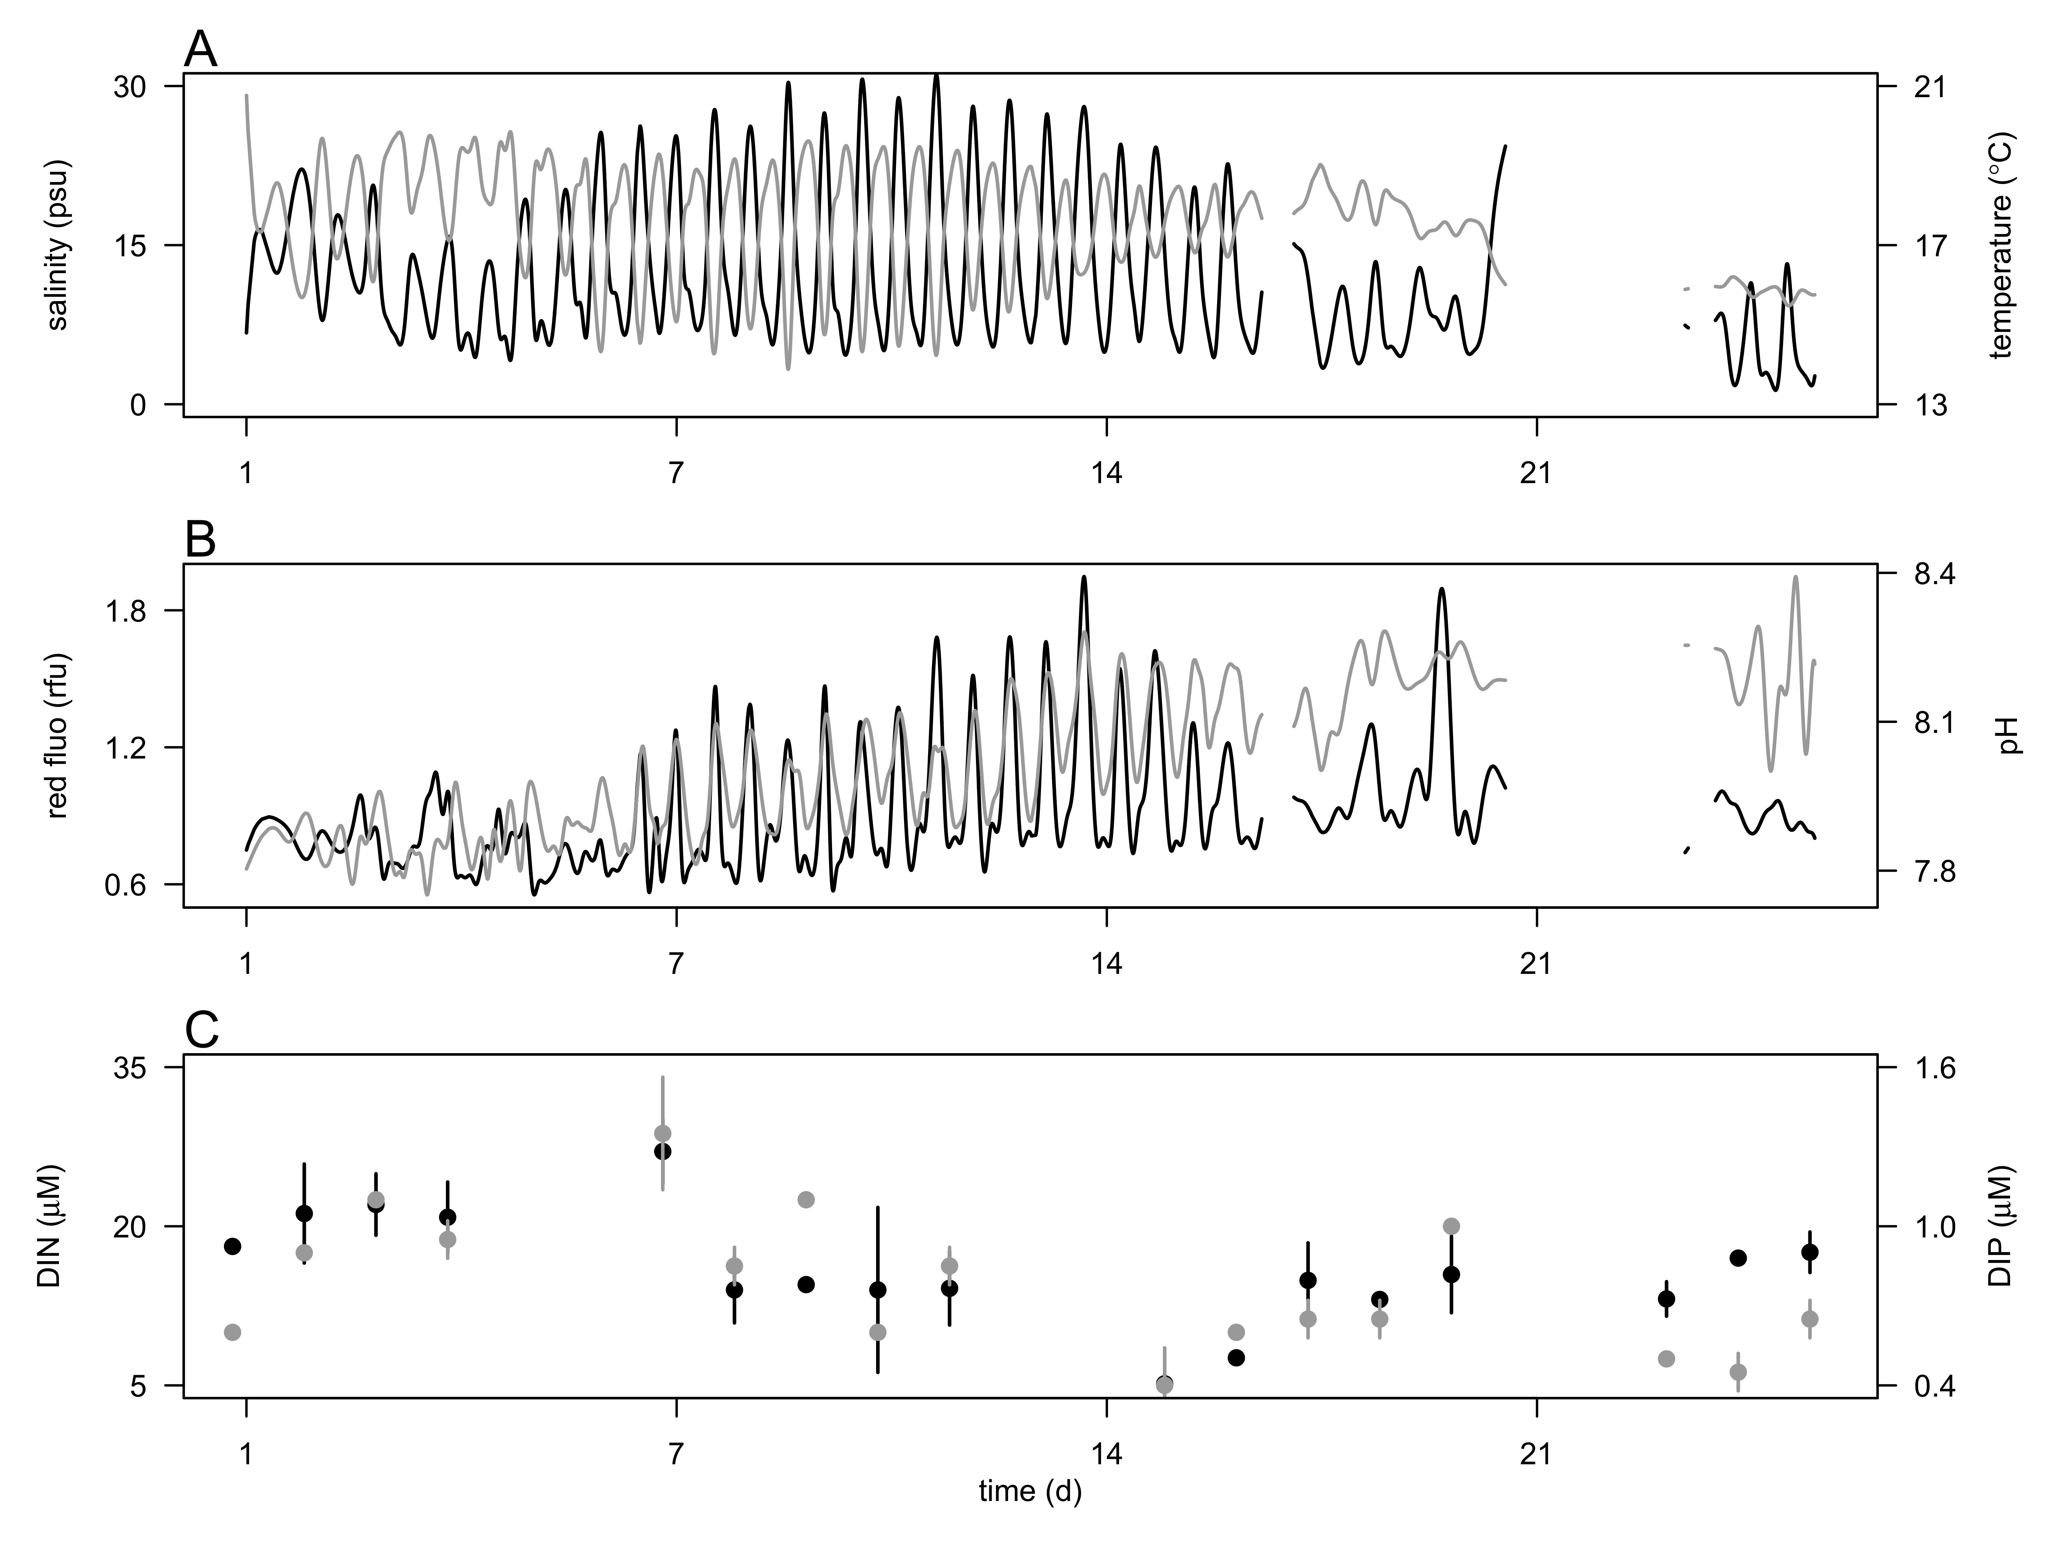

**Fig. 1** Hydrological conditions during the 4 week-survey in the CRE at 2.4 m depth. A) Salinity (psu, black line) and temperature (ºC, grey line). Red fluorescence (black line, relative fluorescence unit, rfu and pH (grey line), and C) concentrations of dissolved inorganic nitrogen (DIN, µM, open circle) and phosphorus (DIP, µM, black circle). Vertical bars represent the ranges of the mean nutrient concentration.

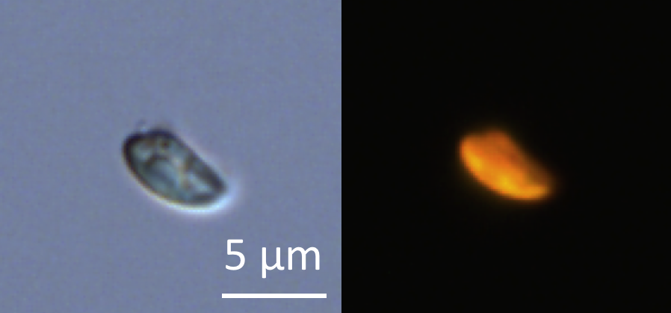

**Fig. 2.** Micrograph of glutaraldehyde-fixed *Teleaulax amphioxeia* cells using transmitted-light (A) and epifluorescence (B) microscopy after cell sorting by flow cytometry. Scale bar is 5 µm.

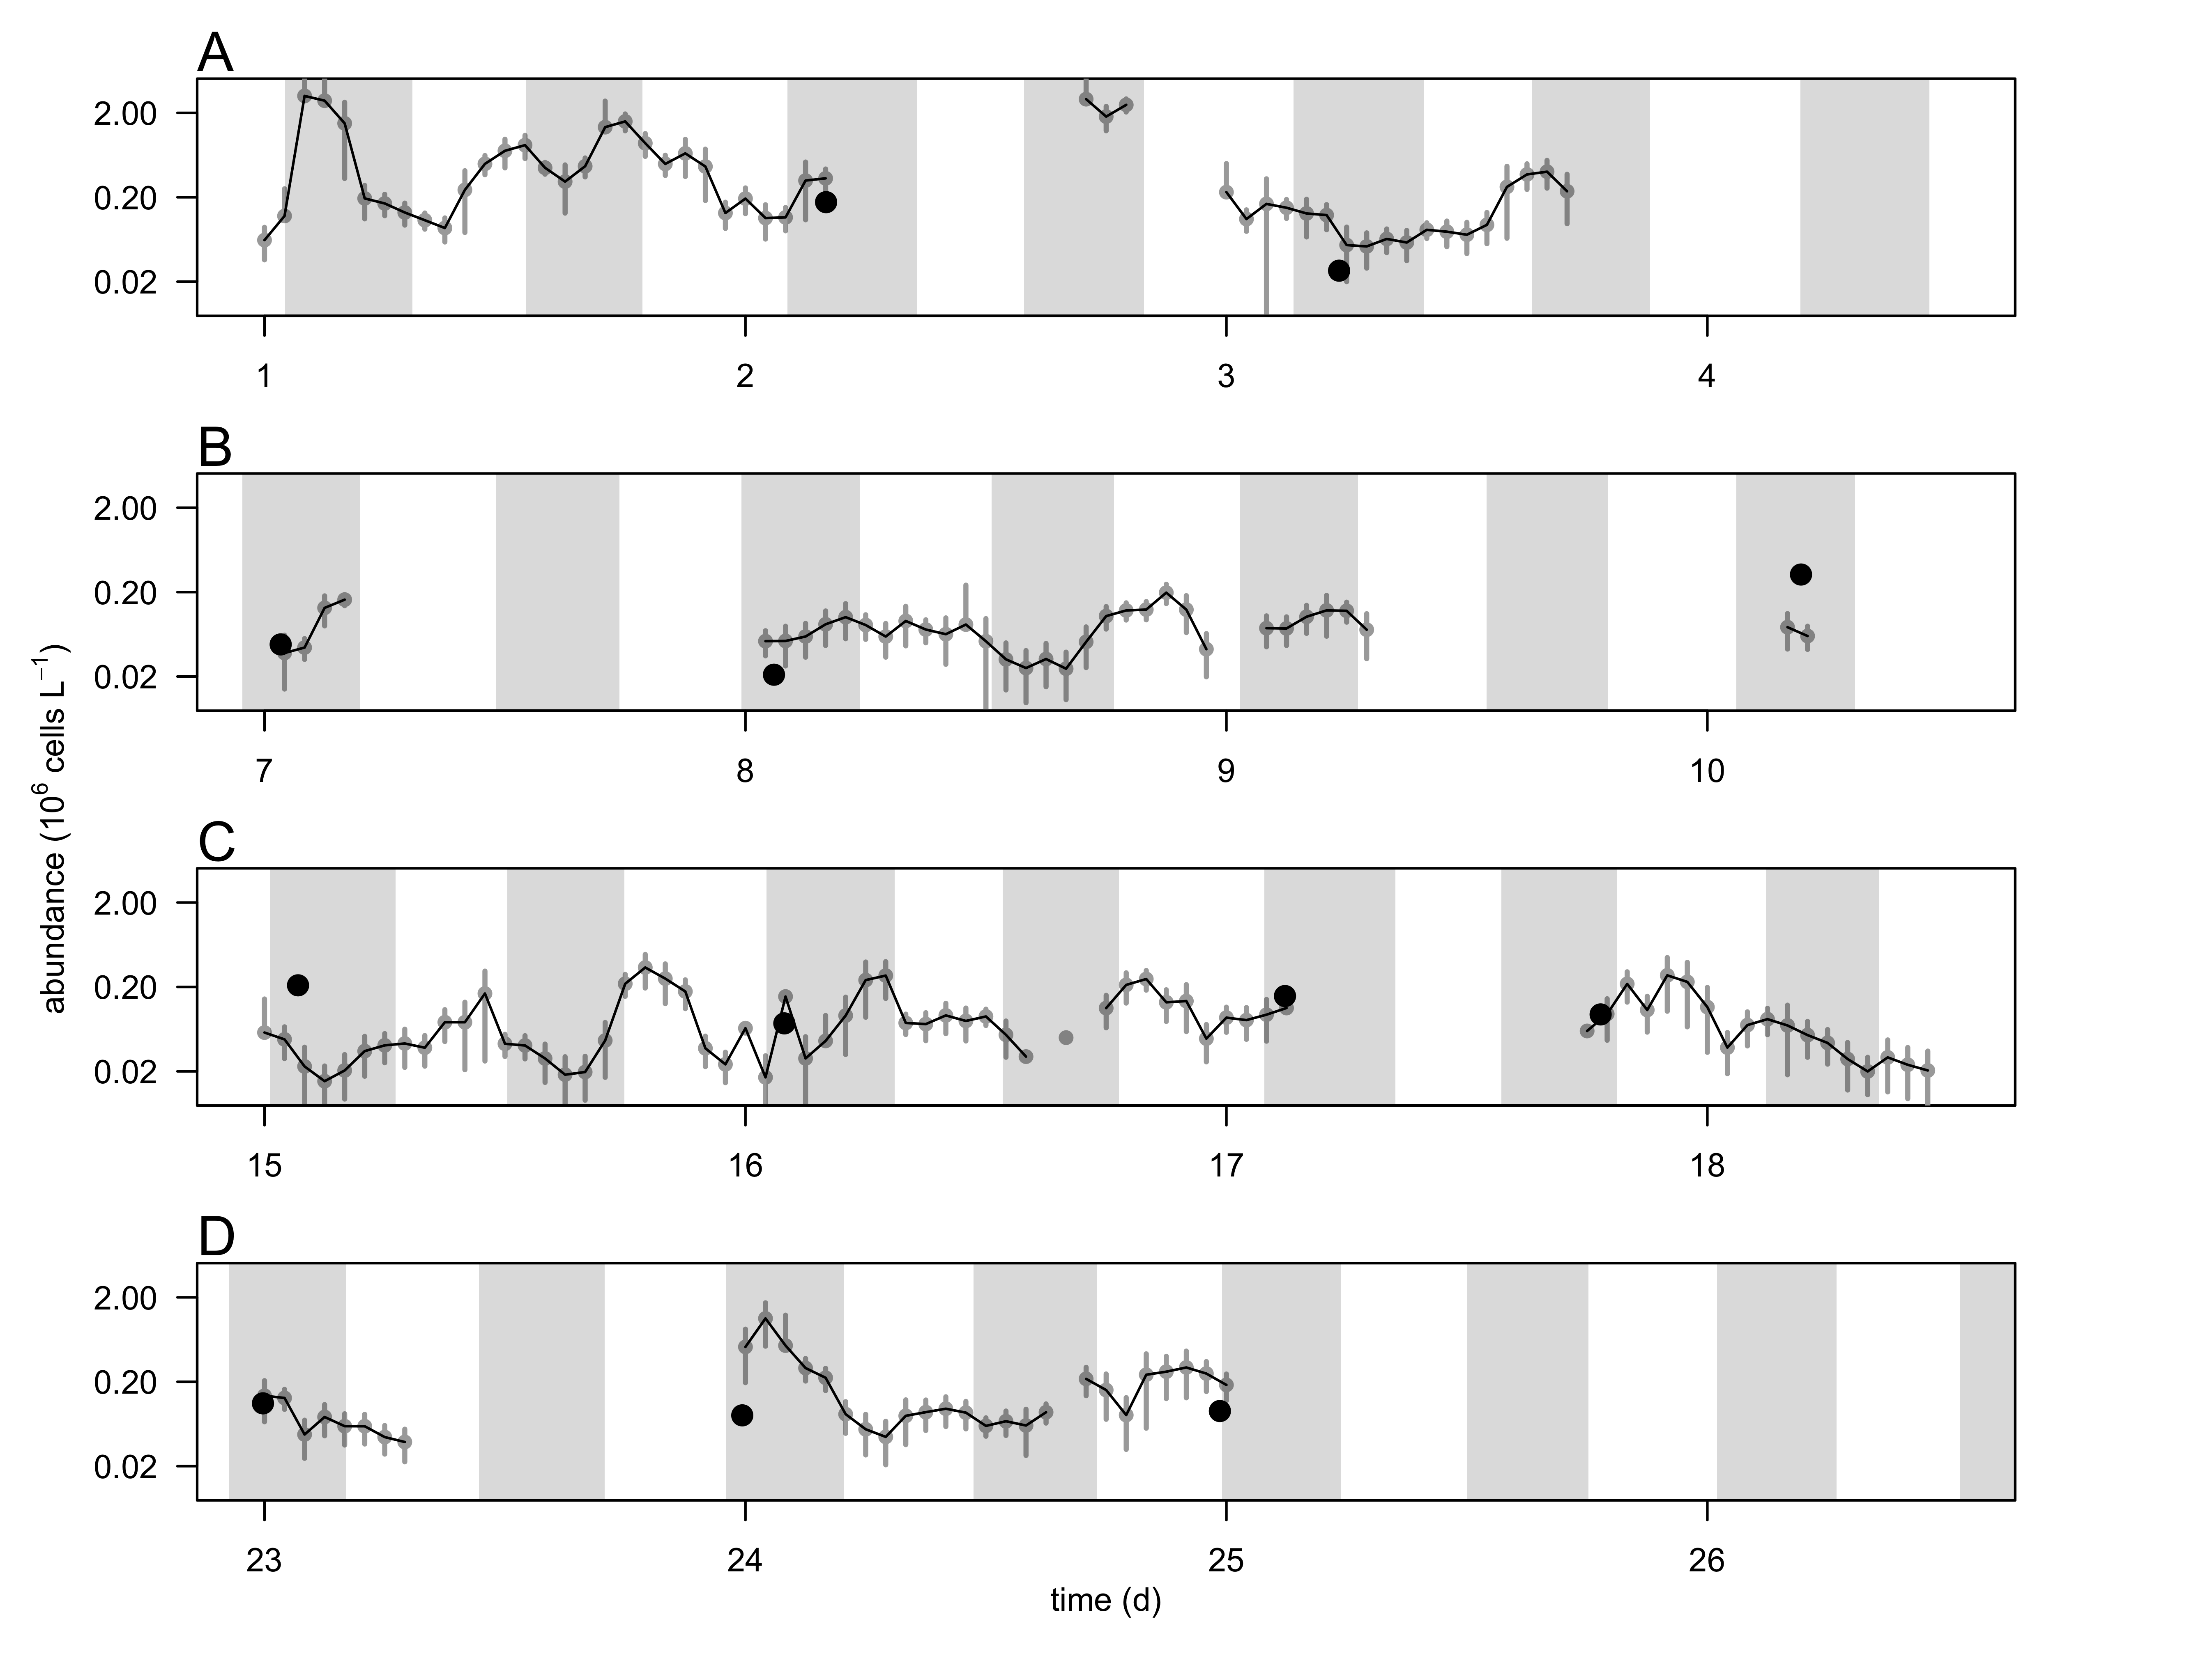

**Fig. 3** Hourly-averaged cell abundances of *Teleaulax amphioxeia* (grey circles and black line, 106 cells L-1) and abundance of *Mesodinium major* (black circles, 106 cells L-1) during the 4-week survey in the CRE (A-D). Vertical bars represent the standard deviation of the hourly-mean cell abundance (n=20). Grey regions represent flood tide. The discontinuity of the *T. amphioxeia* cell abundance is the result of frequent clogging of the flow cytometer due to high concentrations of suspended particle in the water.

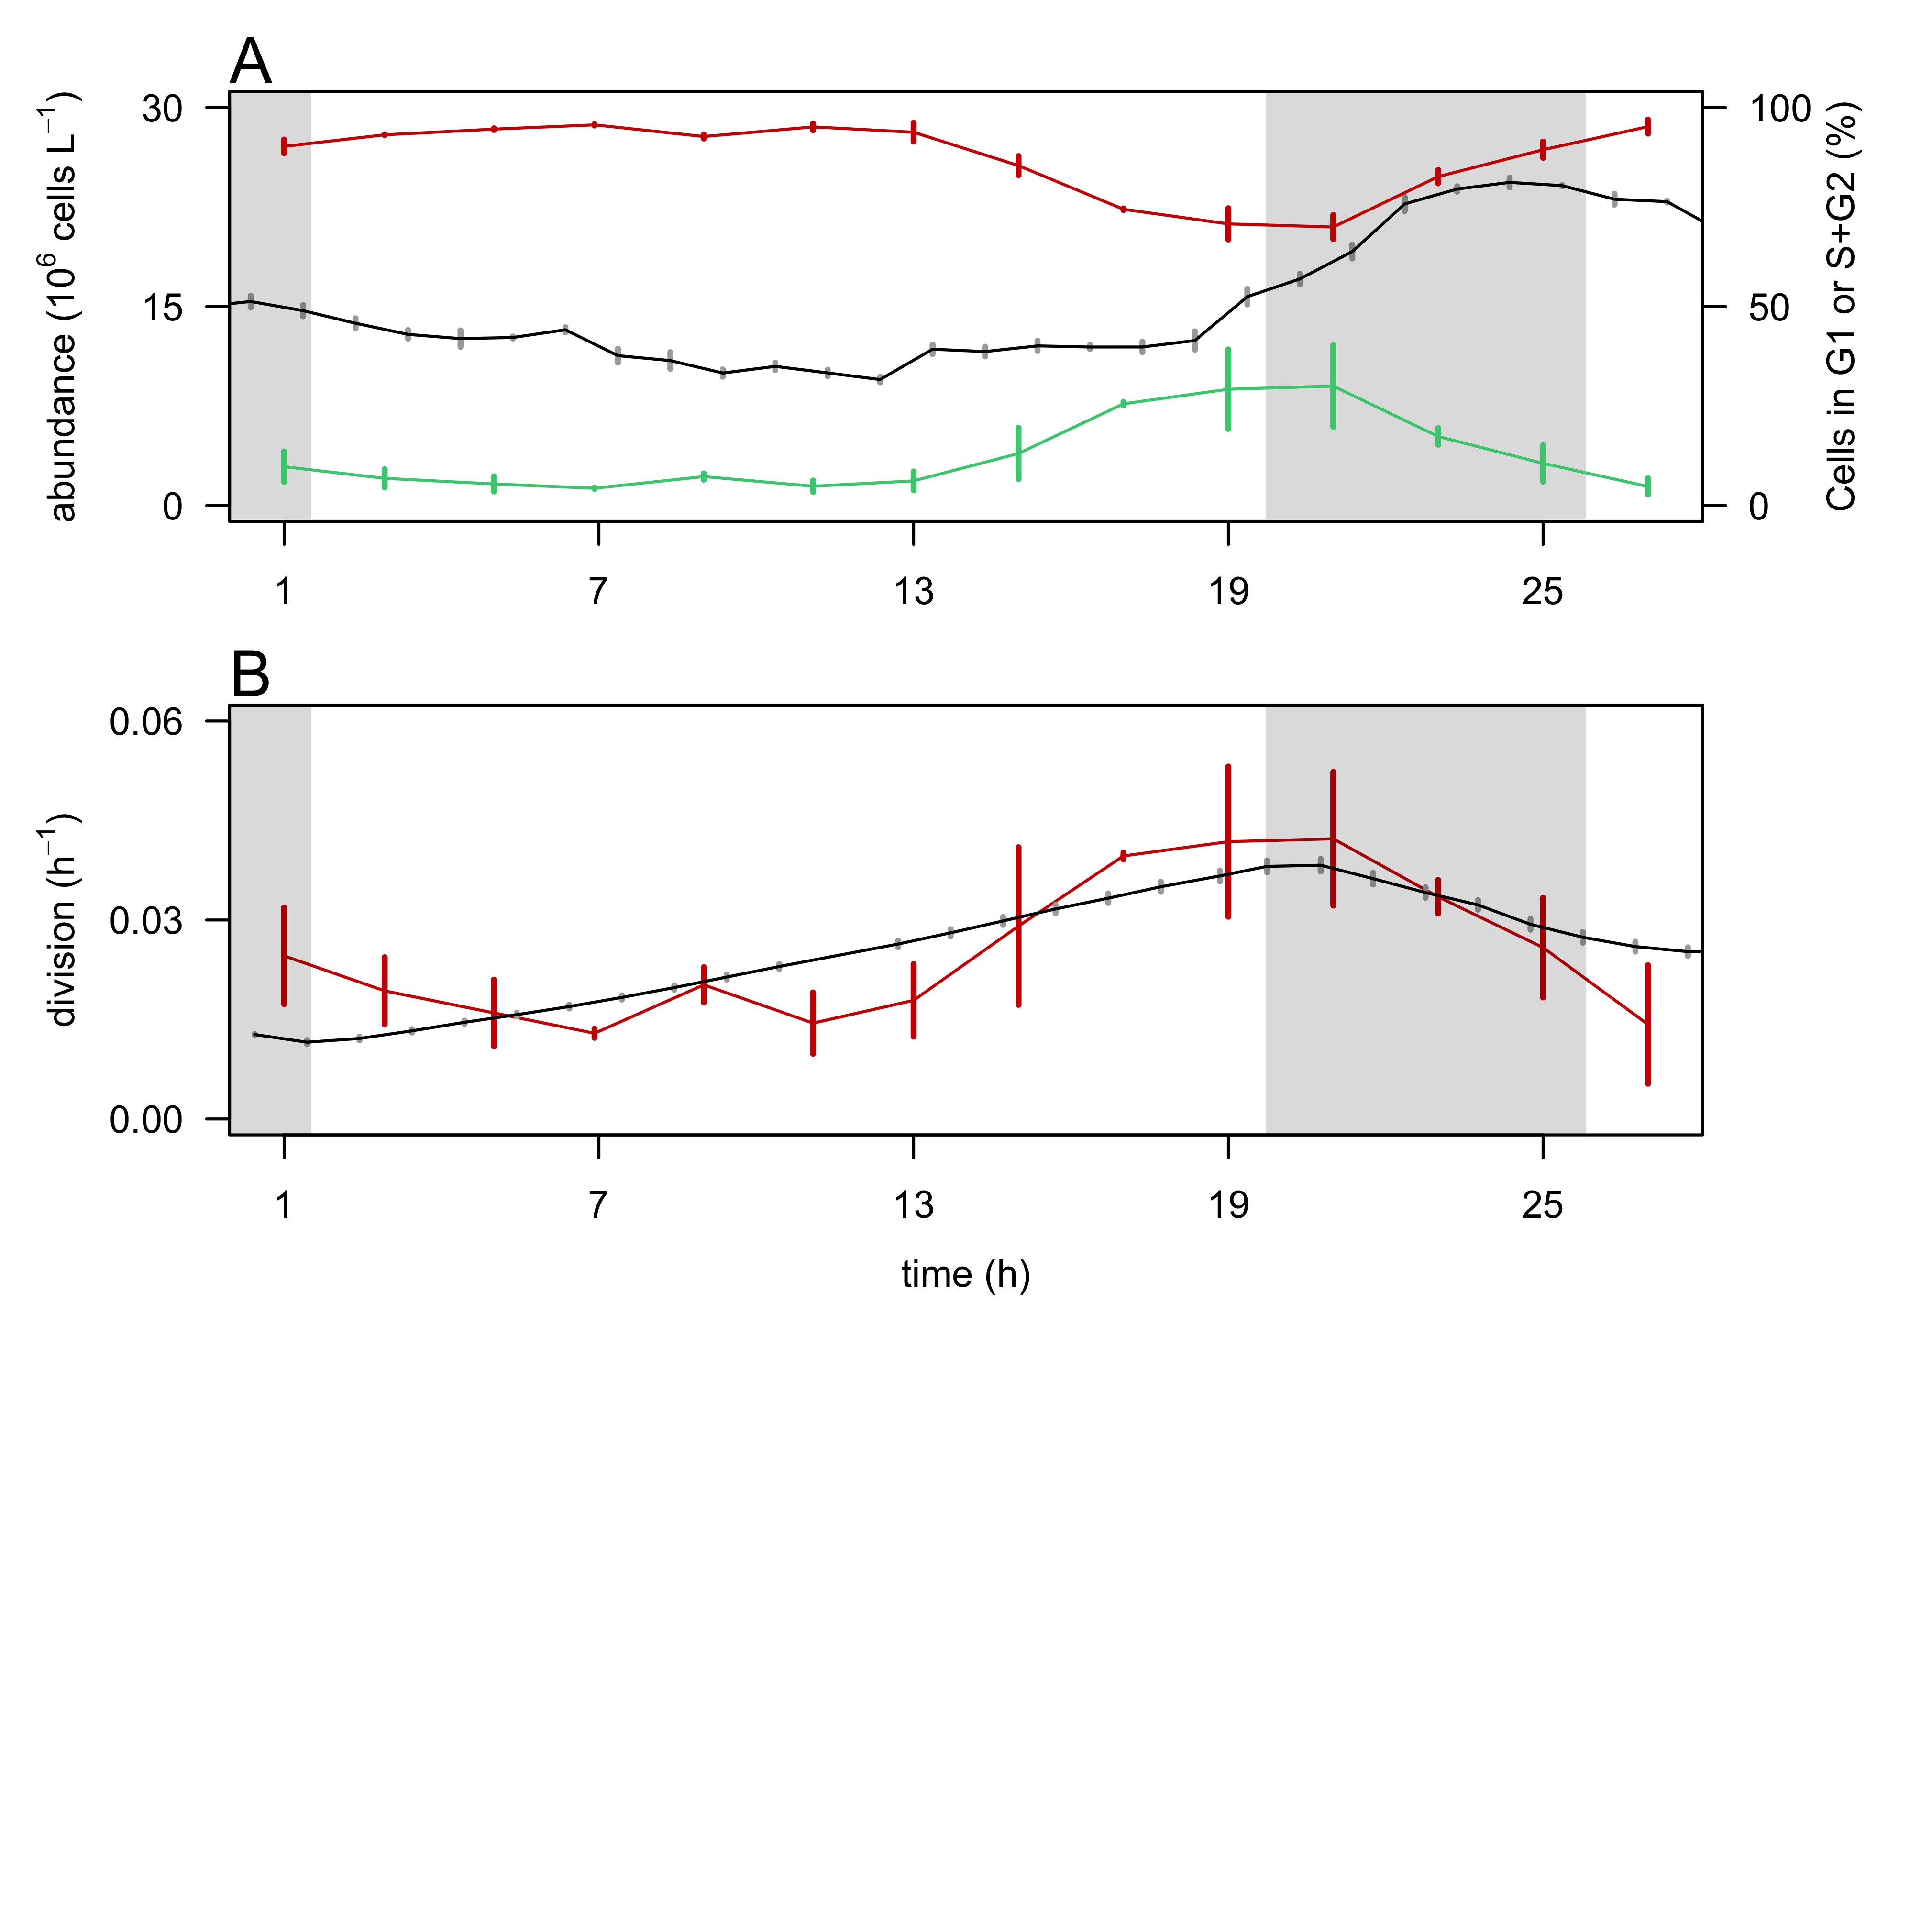

**Fig. 4.** Validation of the size-based division rate model with a cultured cryptophyte isolate during a 28-hr experiment.A) Hourly- averaged cell abundances of *Rhodomonas sp.* (106 cells L-1, black line) and percentage of cells in G1 (red line), and S+G2 (green line) phases. B) Hourly division rates (h-1) based on the relative proportions of cells in S+G2 phases (red line) and based on the size distribution (black line). The grey regions indicate night. Vertical bars represent standard deviations (n=20 for abundances, n=3 for the percent of cells in G1 and S+G2 phases, n=24 for the size-based division rates).

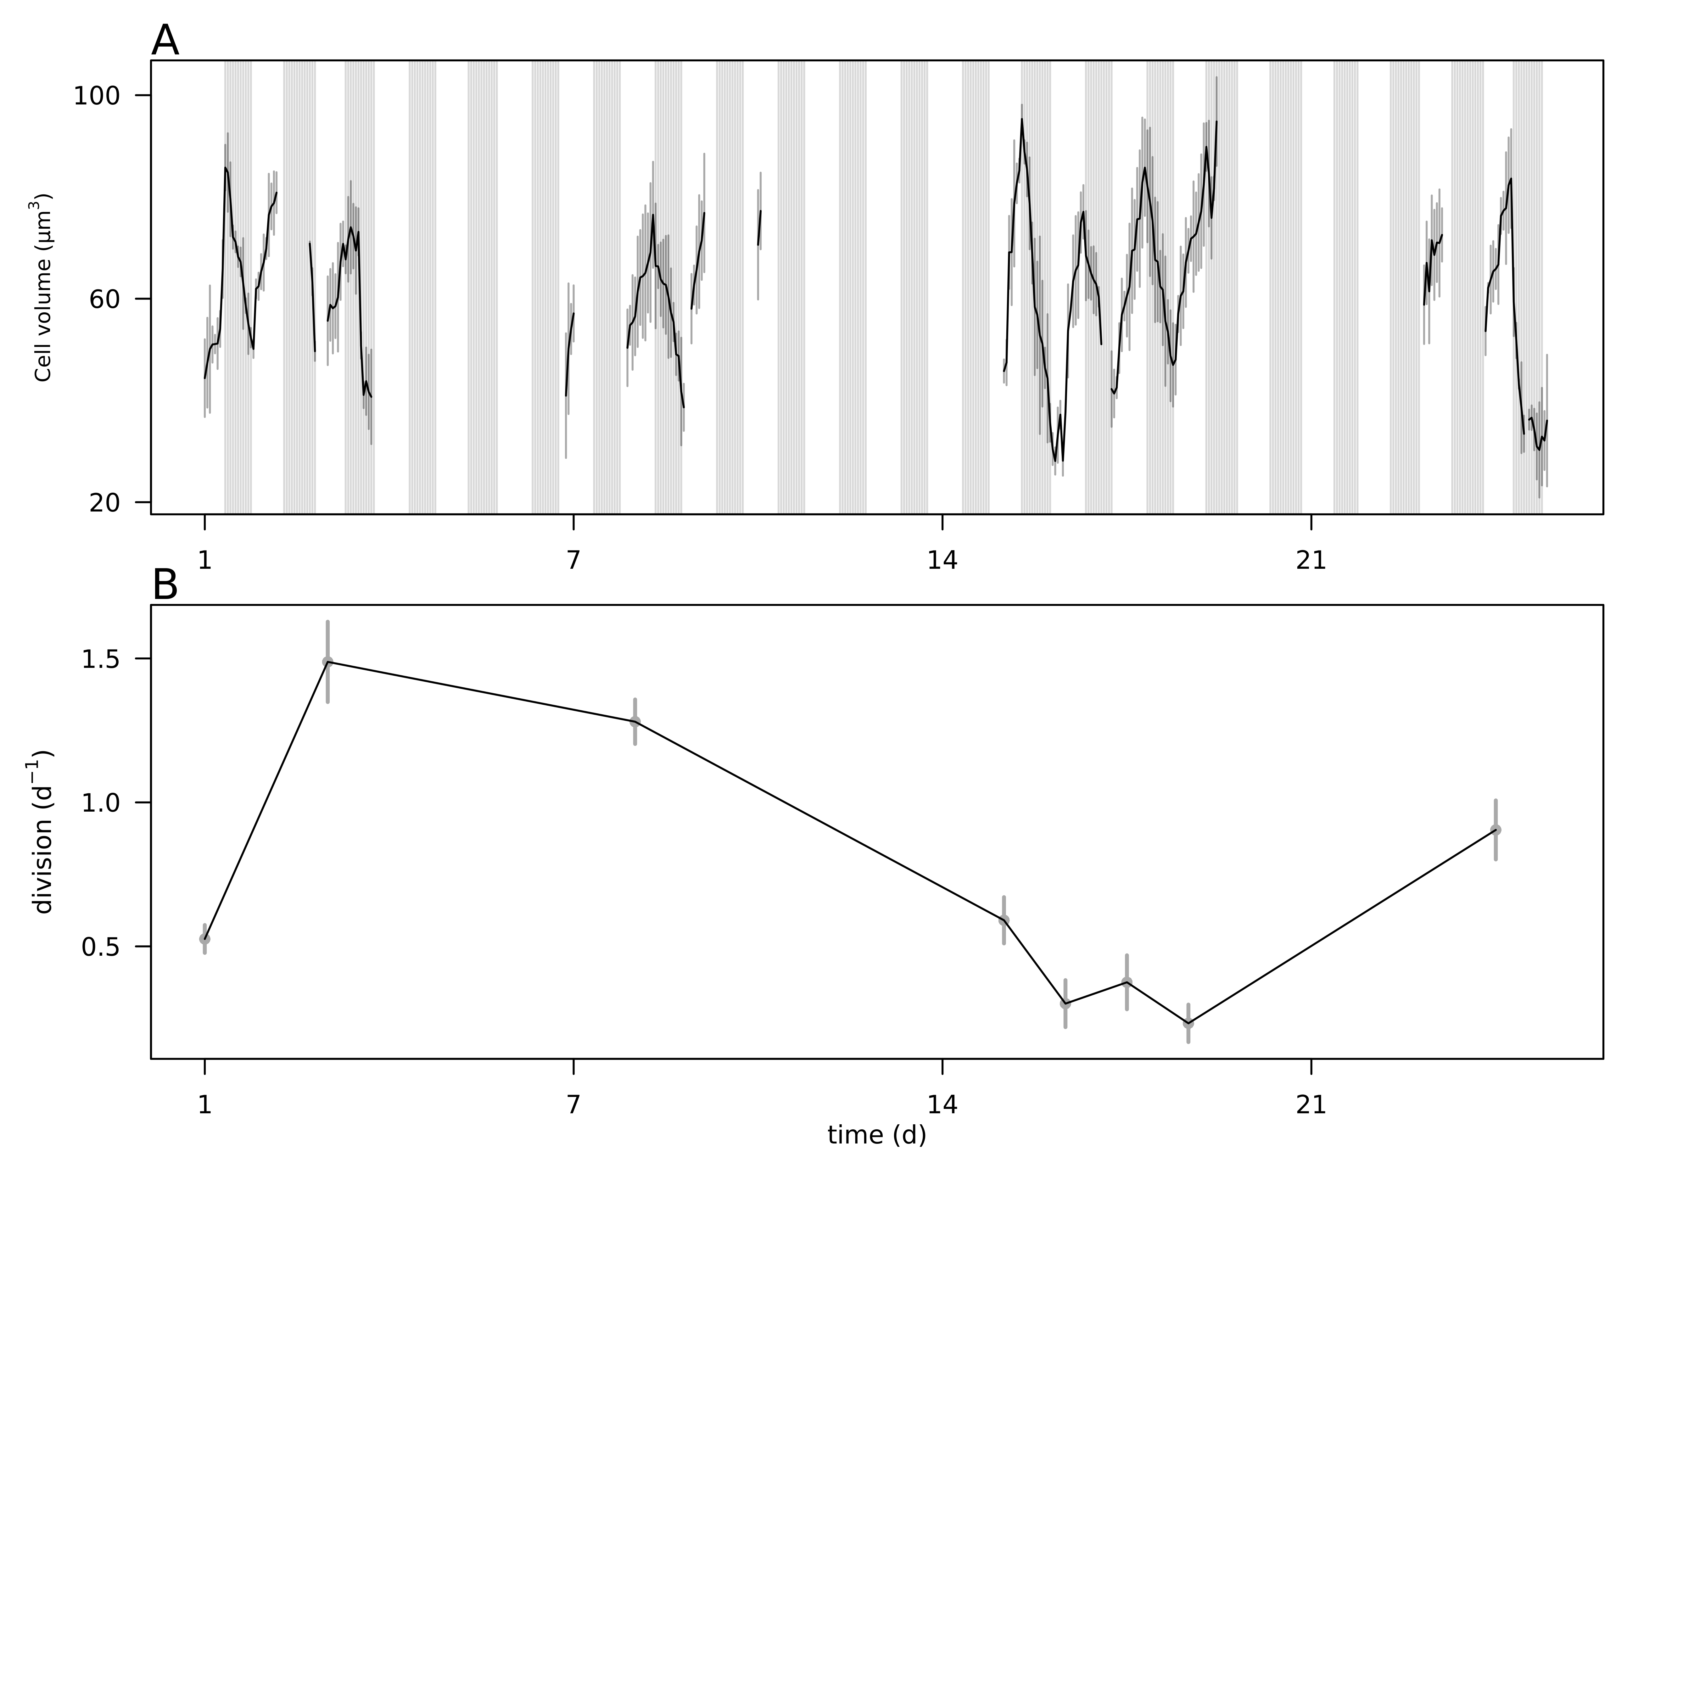

**Fig. 5.** A) Hourly-averaged cell volumes of *Teleaulax amphioxeia* (µm3) estimated by SeaFlow during the survey. Vertical grey bars represent the standard deviation of the hourly-mean cell volume. The grey regions indicate night. B) Daily rates of cell division (d-1) of *Teleaulax amphioxeia* during the survey in the CRE. Vertical bars represent the propagated standard error of the sum of hourly division rate estimates during each of the ten 24 h-period.

*The following supplement accompanies the article*

**Dynamics of *Teleaulax* cryptophytes during red water blooms in the Columbia River Estuary**

**Maria Hamilton, Joseph Nedoba, Katie Maxey, Rhonda Morales, Tawnya Peterson, Megan Schatz, Jarred Swalwell, Peter Zuber, E. Virginia Armbrust, Francois Ribalet \***

* Corresponding author: [ribalet@uw.edu](mailto:ribalet@uw.edu)

*Marine Ecology Progress Series XXX: XX–XX (201X)*

**Supplement.**

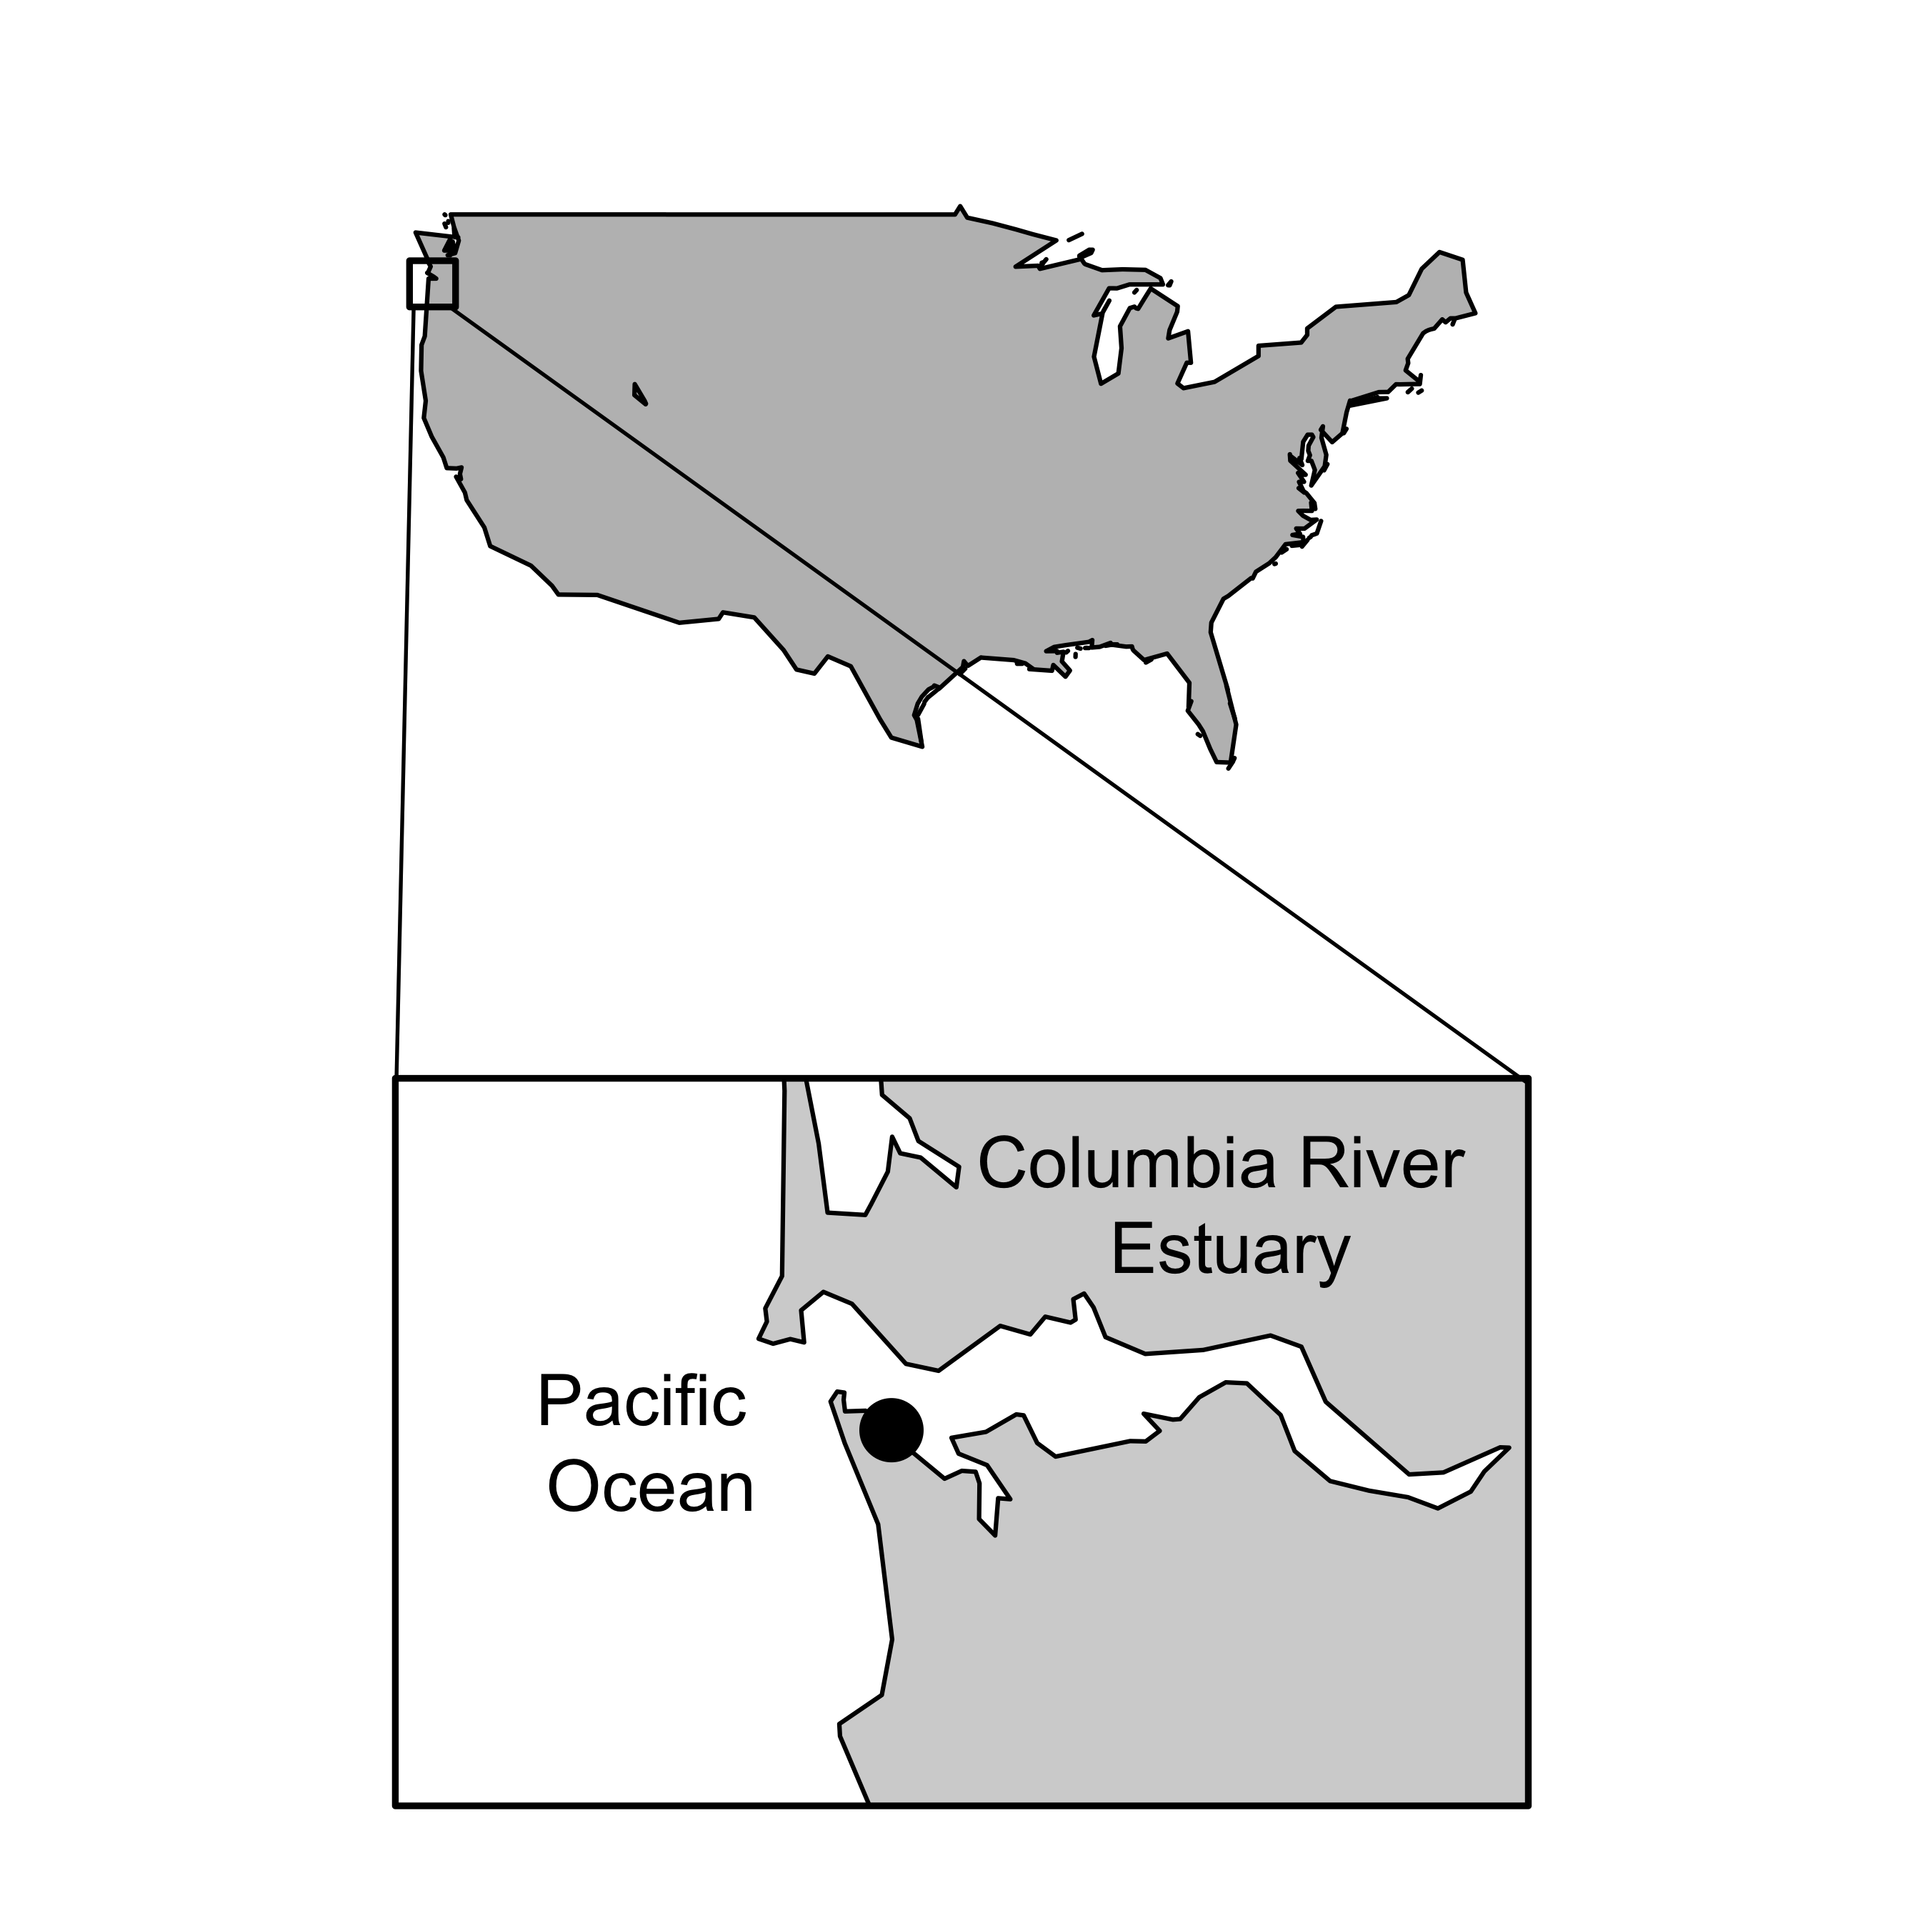

**Fig. S1** Map of the Columbia River Estuary with the sampling site location marked by the black dot.

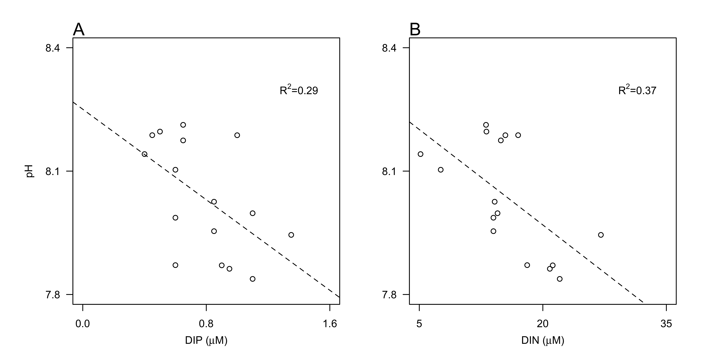

**Fig. S2** Relationship between pH and concentrations of A) dissolved inorganic phosphate (DIP, µM ), and ) dissolved inorganic nitrogen (DIN, as the sum of ammonium, nitrate and nitrite, µM). Dashed lines represent model II linear regression of plotted data and R2 represents the coefficient of determination.

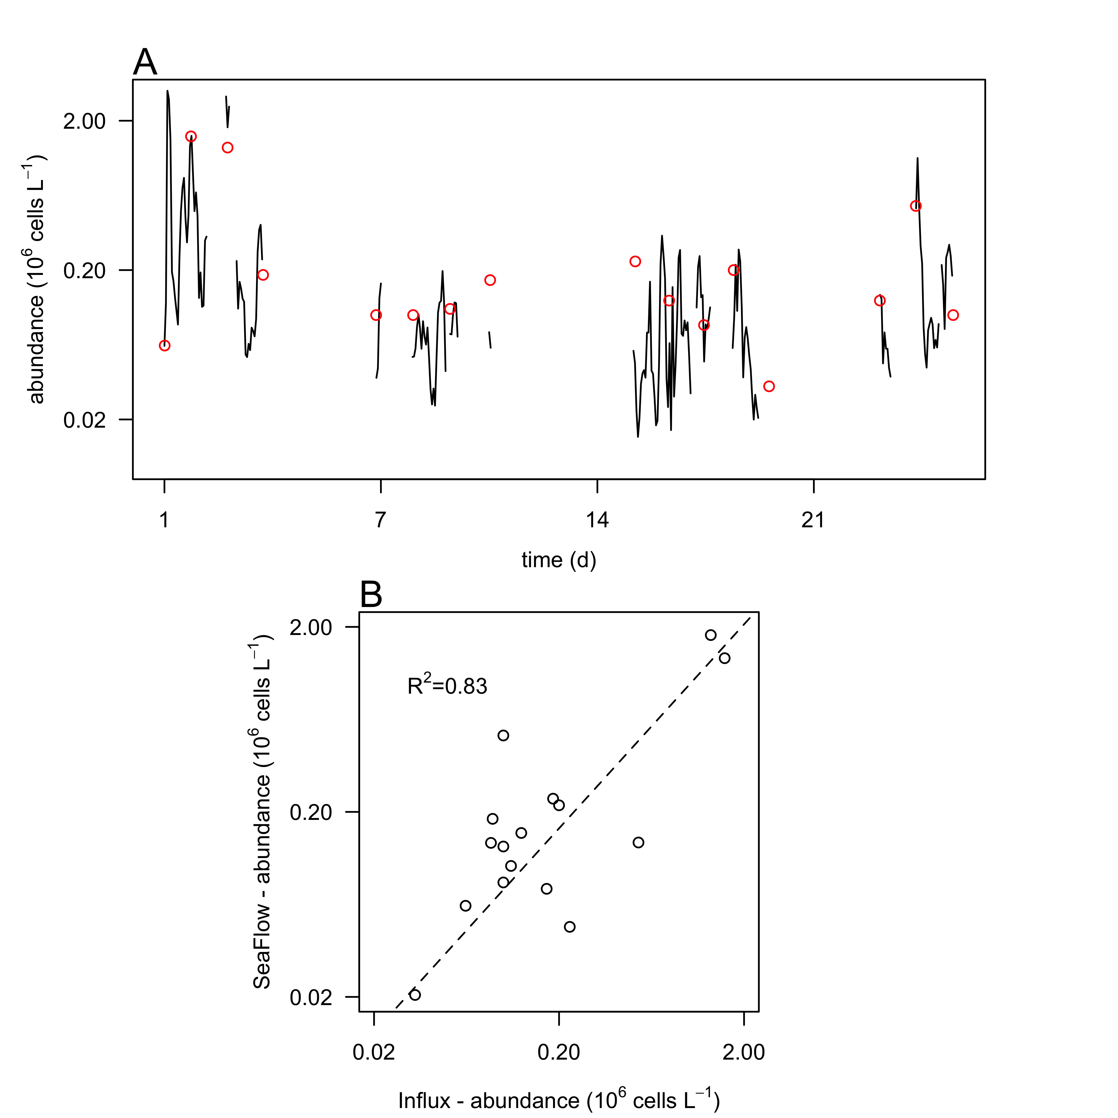

**Fig. S3.** Comparison of cell counts. A) Cell abundances of *Teleaulax amphioxeia* (106 cells L-1) during the survey measured with the SeaFlow instrument (black line) and measured with a BD Influx cell sorter (red circles). B) Correlation of cell abundances measured by the two instruments. Dashed lines represent model II linear regression of plotted data and R2 represents the coefficient of determination.

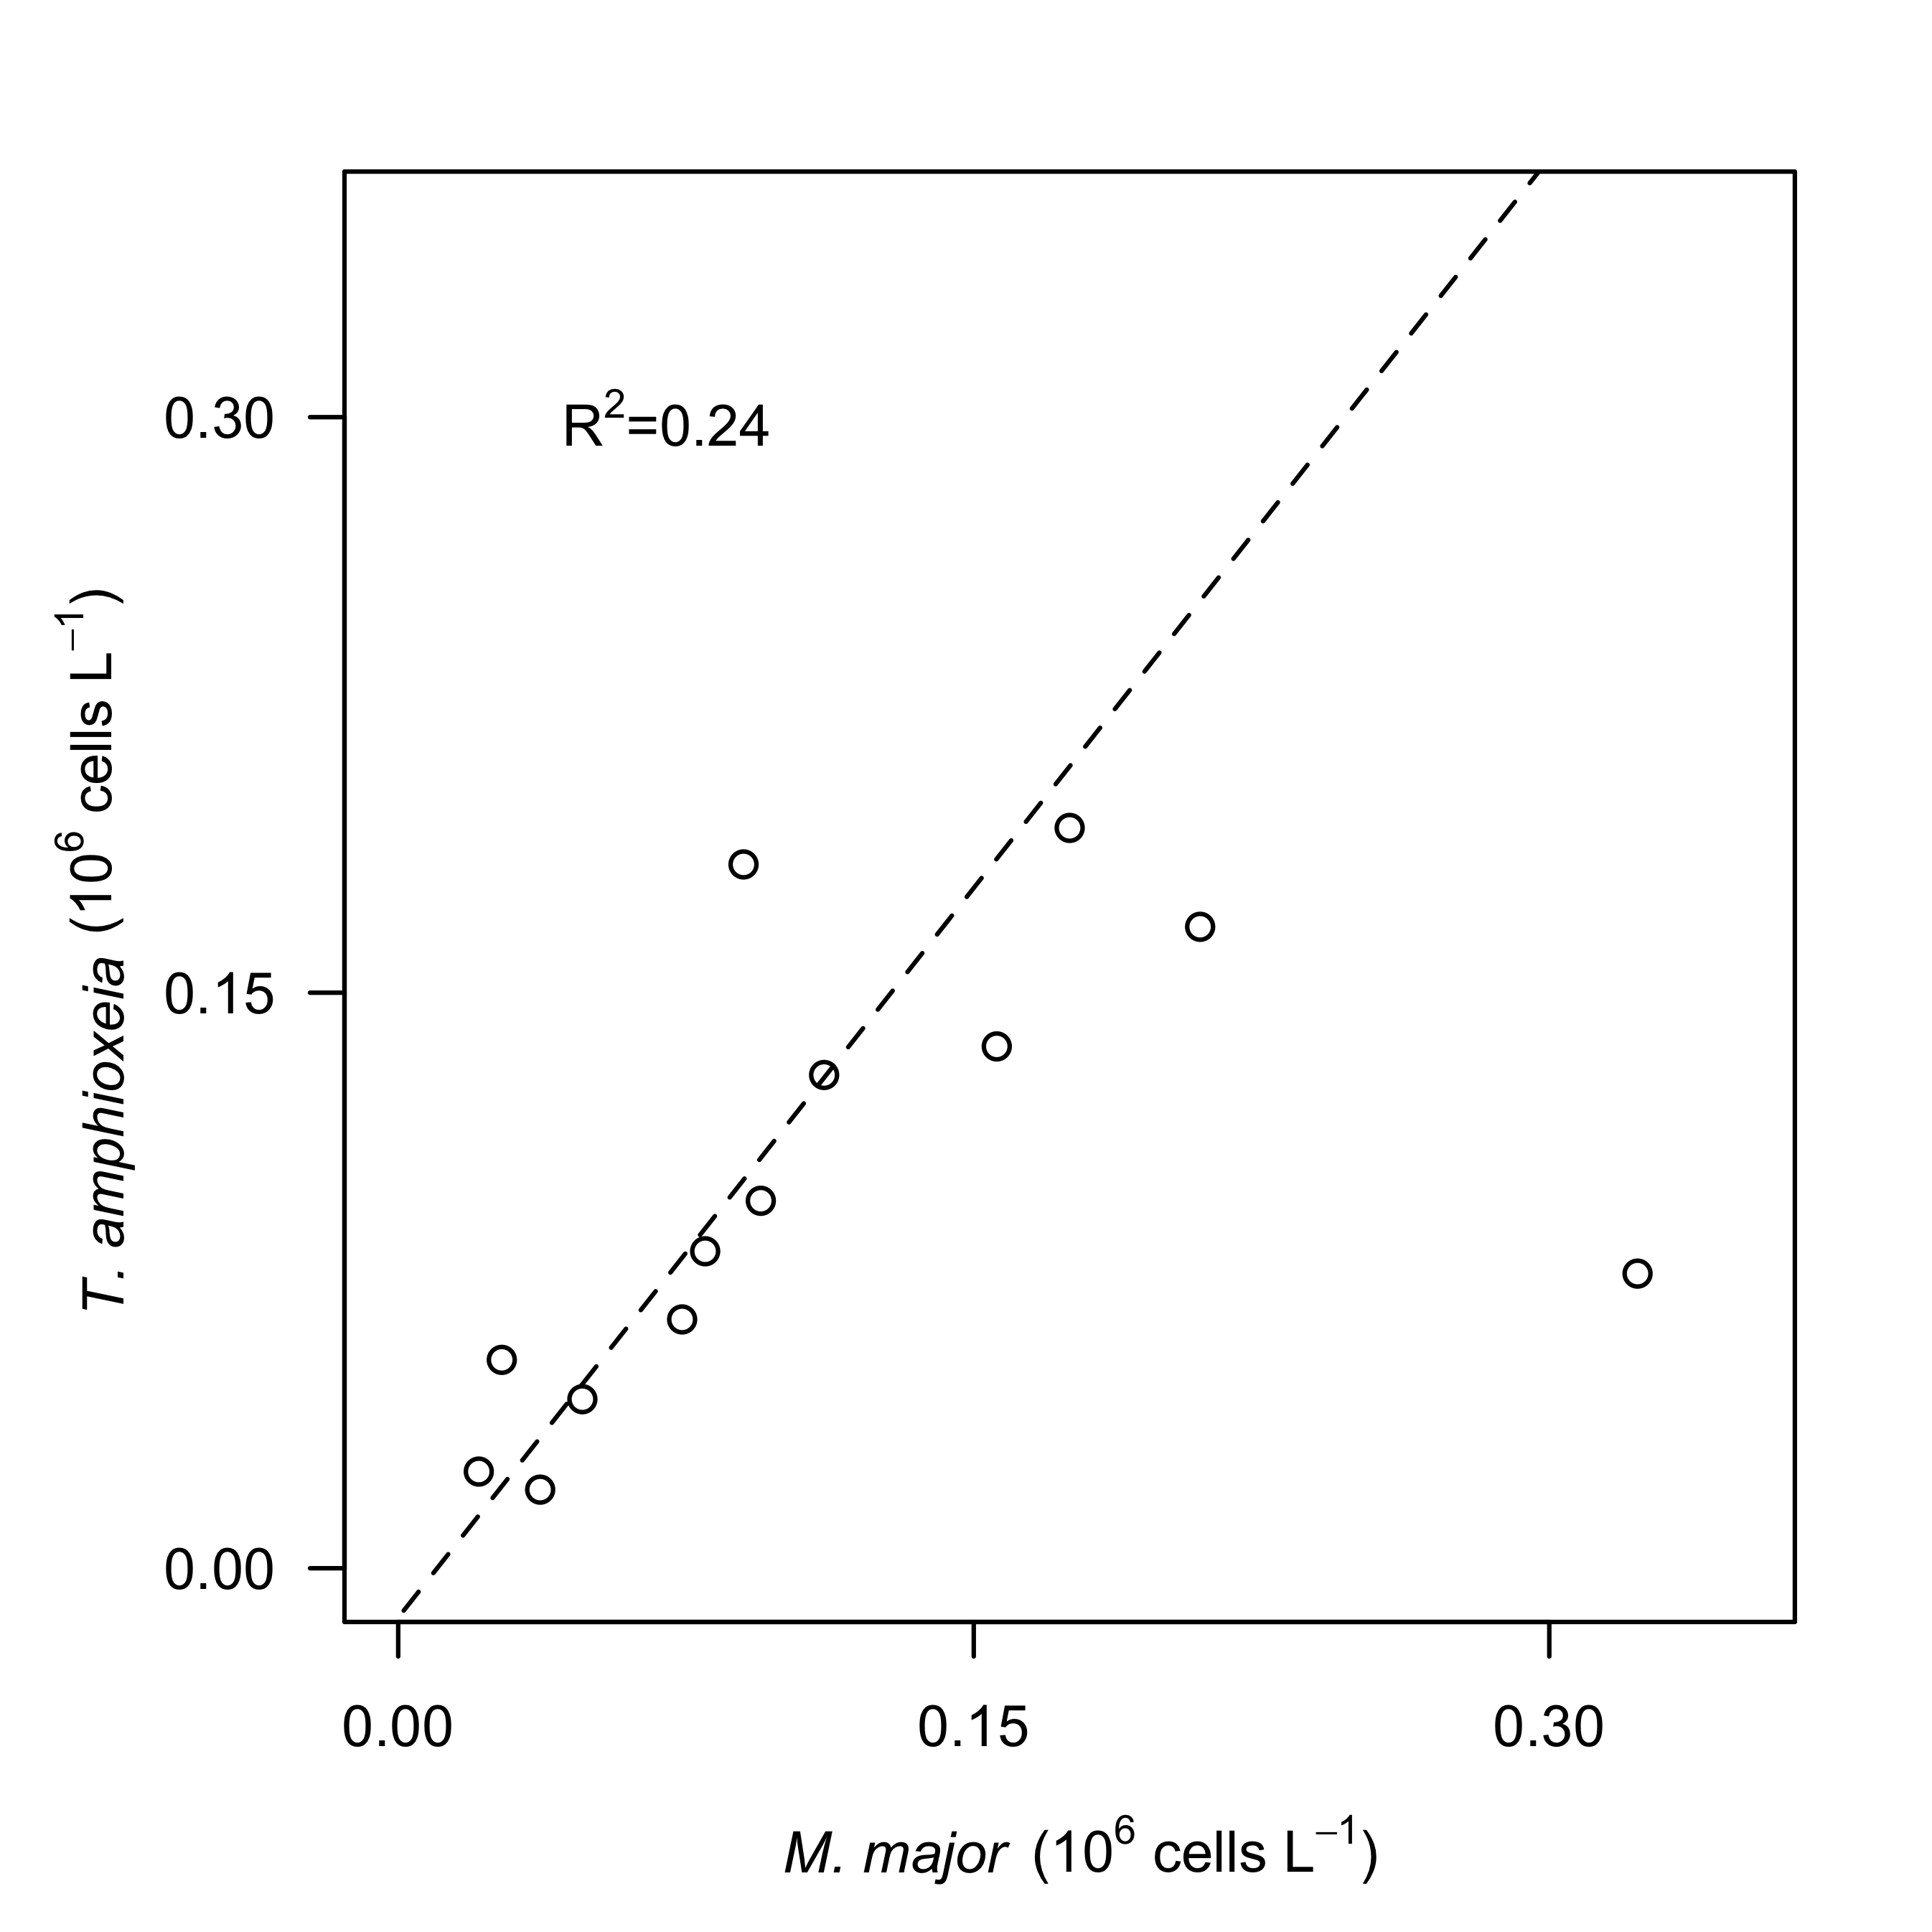

**Fig. S4** Relationship between hourly-average cell abundances of *Teleaulax amphioxeia* (*T. amphioxeia* 106 cells L-1)and abundances of *Mesodinium major* (*M. major*, 106 cells L-1) during the survey in the CRE. Dashed lines represent model II linear regression of plotted data and R2 represents the coefficient of determination.

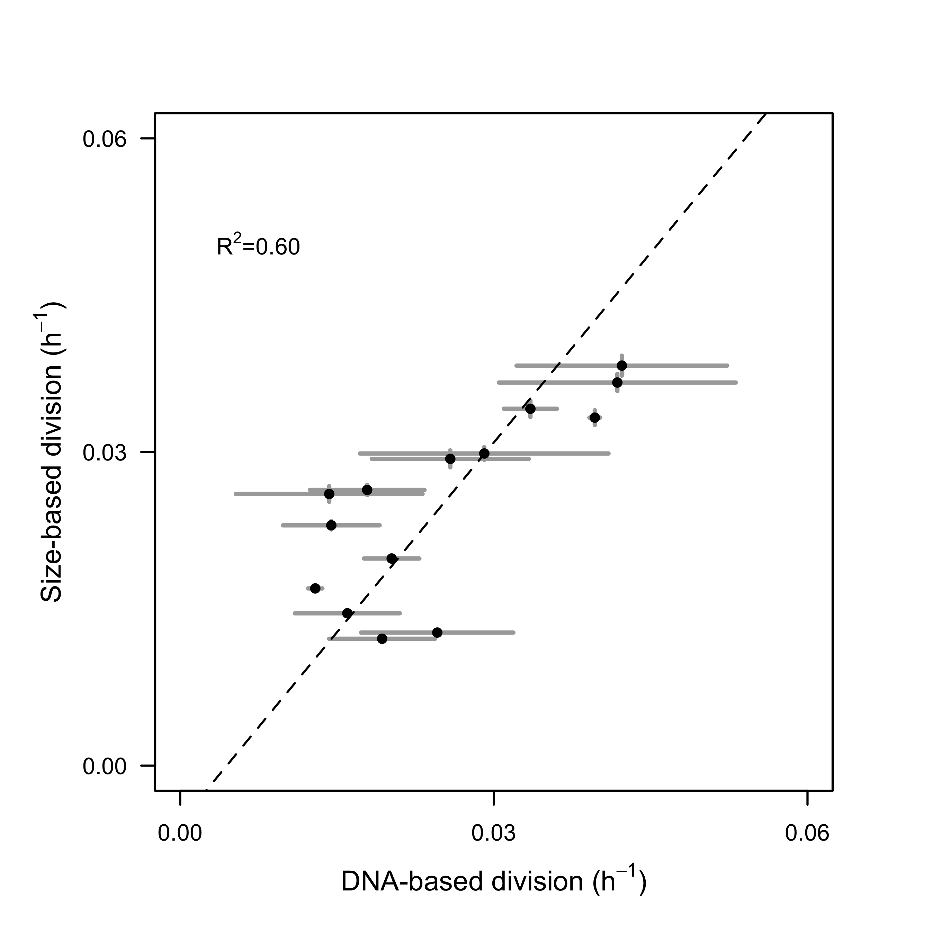

**Fig. S5.** Comparison of size-based division rate estimates (h-1) with DNA-based estimates of division rates (h-1) of *Rhodomonas* sp. in cultures over the course of 28-hr. Dashed lines represent model II linear regression of plotted data and R2 represents the coefficient of determination.

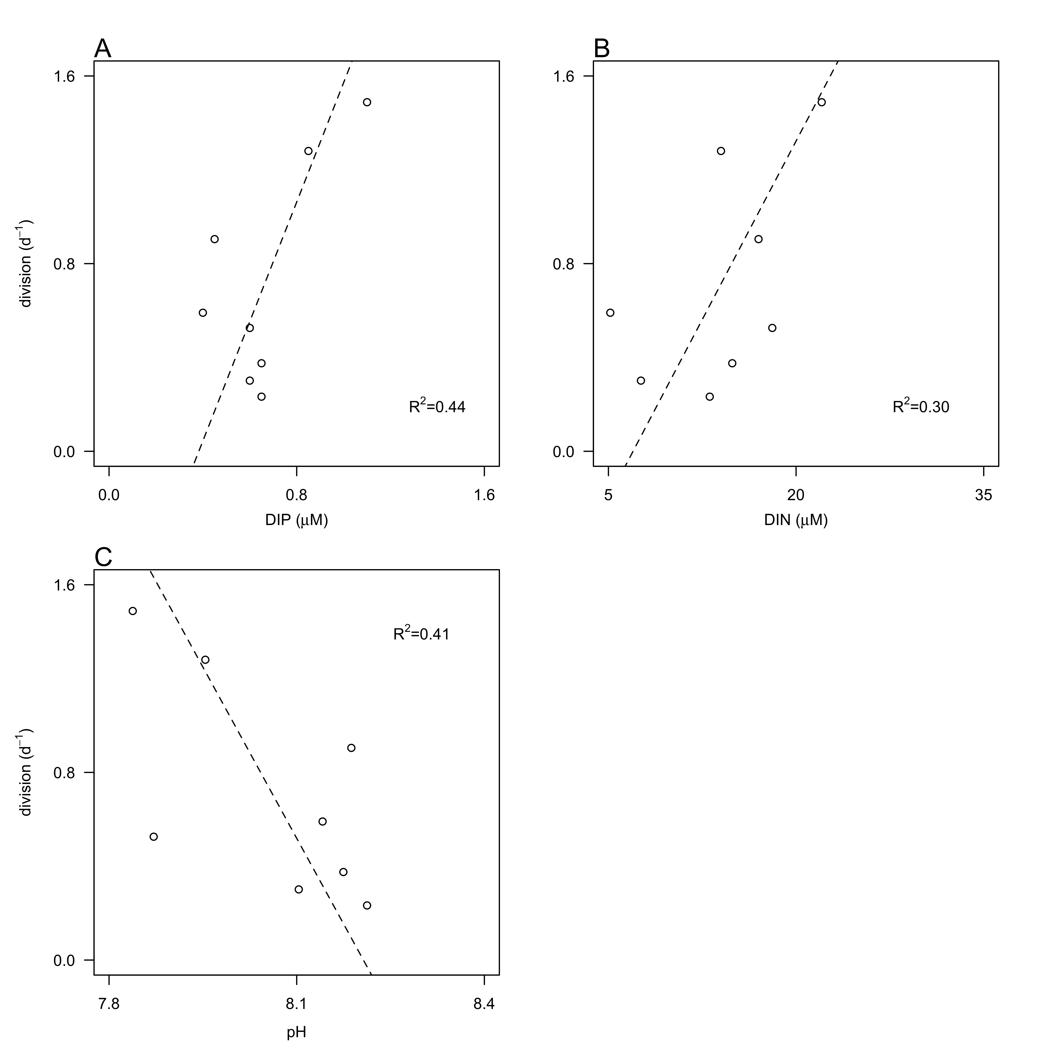

**Fig. S6** Relationship between division rates (d-1) of *Teleaulax amphioxeia* with daily-averaged concentrations of dissolved inorganic A) phosphate (DIN, µM) and B) nitrogen (DIN, µM) and pH during the survey. Dashed lines represent model II linear regression of plotted data and R2 represents the coefficient of determination.